MPC- 416

January 1, 2013- December 31, 2013

**Project Title:**

Development and Testing of Crashworthy Ipe Bridge Rails

**University:**

Colorado State University

**Principal Investigator:**

Paul Heyliger

Professor

prh@engr.colostate.edu

970-491-6685

**Research Needs:**

Bridge and guard rails are extraordinarily common along roads and highways around the world (Ritter et al. 1999, Wacker and Smith 2001). Even the most low-traveled rural bridge likely has rails installed for safety, and of course interstate highway systems have rails that can vary from concrete along bridges to cable lines across medians and metal railings at shoulders. Various types of railing have been studied for decades, and excellent design guidelines exist for nearly every class of railing. Typical types of railing can include formed steel in the shape of convex shell structures, simple solid wood timbers spliced with lap joints, hollow steel or other metal tubing that can be arrayed in either its strong or weak direction to adjust the stiffness at impact, glu-lam beams attached to solid wood posts, and cable “rails”. Representative configurations for these types of railings are shown below in Figure 1.

Clearly, there are massive differences in cost and effectiveness between various barriers, and there are only limited numbers of studies that have attempted to compare the various types of railing (Shankar et al. 2000, Plaxico et al. 2000). In this study, we will complete a thorough review of all previously published studies of guardrails (including both performance and cost) throughout the United States along with collecting data on guard rail events in Colorado. But the primary emphasis of this work is exploring the use of an extremely durable and tough alternative structural material: the hardwood commonly known as ipe, also known as Brazilian walnut (ocotea porosa). Ipe has tremendous benefits compared to existing alternatives and has yet to be used in conjunction with transportation structures. In fact, there are almost no studies related to its structural performance. This is in part because it is an imported wood, and has a slightly higher cost than common structural wood species. But it appears to have excellent potential for use in applications where durability, environmental stability, and strength/stiffness are paramount.

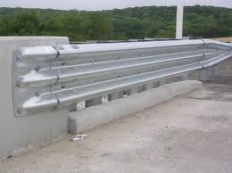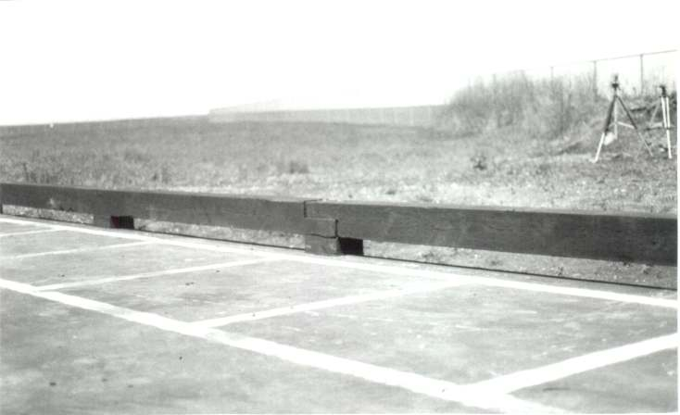

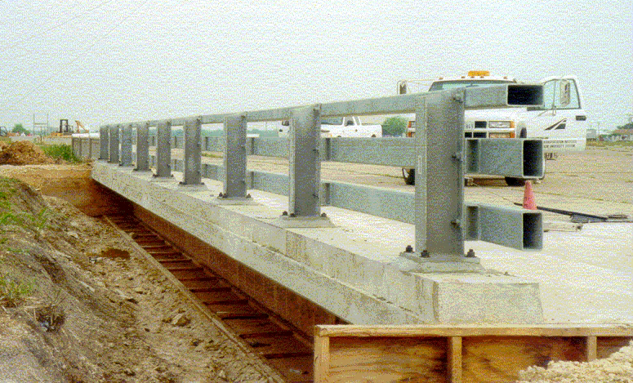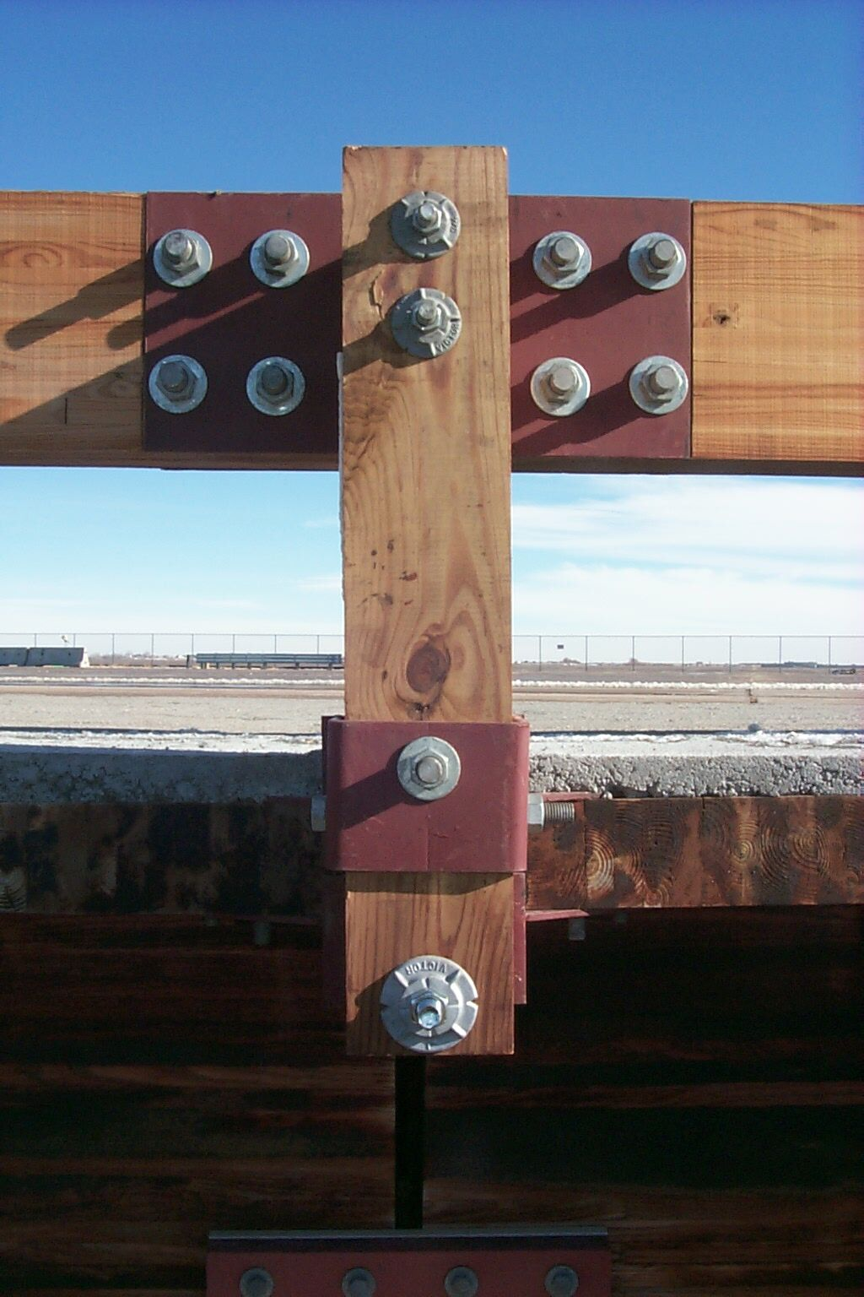 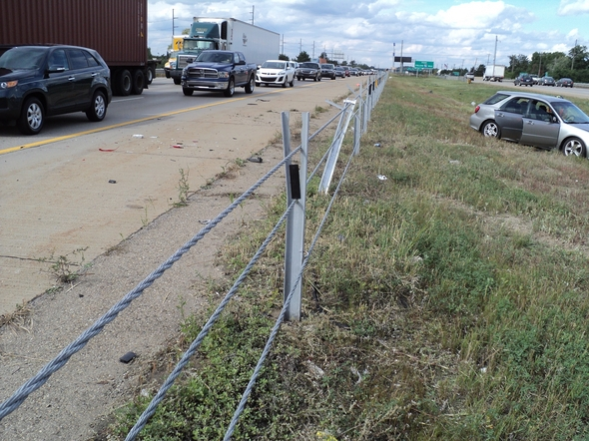

Figure 1. Clockwise from upper left: (a) The standard thrie-beam guardrail, (b) typical curb-type timber bridge rail, (c) cable shoulder barriers after an accident, (d) connection details for a solid wood post and glulam railing, and (e) steel tubing rails with I-section posts.

There are some limits to current practice, and rail testing appears to possess a mildly ambiguous standard. Even systems that are FHWA accepted to specified NCHRP Report 350 test levels may have passed a relatively low number of crash tests. In extreme cases, this could be as little as a single test. By far the most common guardrails are either treated or untreated metal railing. These usually appear as w-beam sections and have relatively low cost and high strength. However, they usually suffer permanent deformation after a crash and also lose much of their structural capacity. There have been a number of other designs proposed for so-called “aesthetic” barriers that modify the surface of usual crashworthy barriers in design patterns, but physical testing by Caltrans has shown that even slight modifications from crashworthy surfaces have resulted in barrier failure.

In Figure 2, several real-world rail failures/repairs are shown that indicate the wide variability in failure mode and material type. There is not a common mode of failure such as would occur, say, in pure beam bending. Instead, there can be a combination of post/rail failure or a local foundation collapse. Performing a full study of failure modes is beyond the scope of this study. Instead, we focus on local impact behavior of ipe rails compared to other material candidates. There have been several numerical models performed for bridge railing systems (Atahan and Cansiz 2005, Liu et al. 2011), and these results will also be incorporated into an assessment of existing methods.

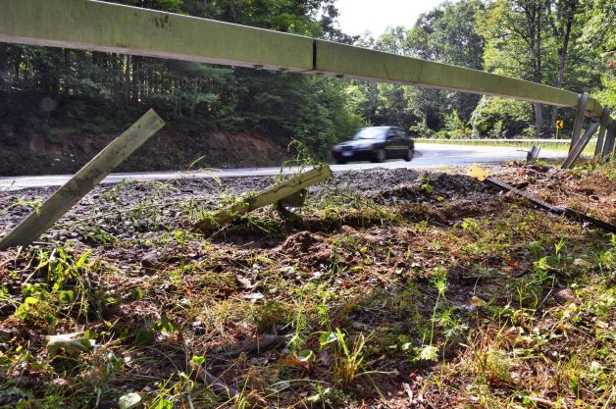 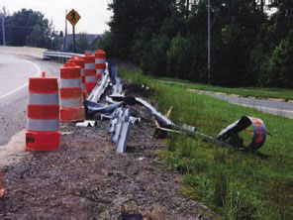

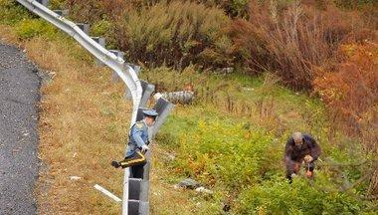 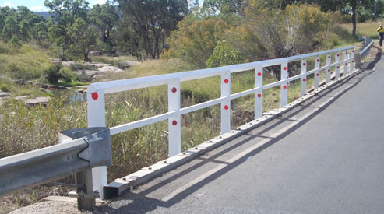

Figure 2. Examples of damaged guard rails, clockwise from upper left: (a) at the site of a fatal motorcycle accident in New York (2012), (b) damaged rails from a single-car crash (2011), (c) breakaway post-rail system repair in Australia, reported to be installed for under $9000 (2012), and (d) damage from single-car impact in New Jersey (2011).

This project focuses on the design and performance of ipe bridge rails in an application that is similar to the lower right picture of Figure 2. Ipe is one of the densest hardwards that is commercially available in the United States. It has the same fire rating as both steel and concrete, with an ability to resist flames much longer than softer woods. It has a natural oil that repels insect infestation and is also resistant to mildew and decay, raising the possibility of its use in coastal or humid environments. In terms of durability, we quote from the online database at [www.wood-database.com](http://www.wood-database.com): “Ipe is among the most durable lumbers on earth, with exceptional resistance to decay, rot, and insect attack. Ipe was reportedly used for the boardwalk along the beach of New York City’s Coney Island, and was said to have lasted 25 years before it needed to be replaced: an amazing lifespan given the amount of traffic and environmental stresses put upon the wood.” Its properties are compared with competitors in Table 1.

The primary disadvantage is related to cost. It is approximately 30 percent more expensive than cedar or pine. Additionally, ipe is difficult to work with. Holes must be pre-drilled, cutting can lead to a blunting of blades, and gluing surfaces can be somewhat challenging.

|  |  |  |  |  |  |  |
| --- | --- | --- | --- | --- | --- | --- |
|  | Dried wt | Spec grav | Janka hard | MOR | MOE | Crushing |
| SouthernPine | 570 | .47/.57 | 3.07 | 88.3 | 12.3 | 49.2 |
| Douglas-Fir | 570 | .45/.57 | 2.76 | 86.2 | 12.2 | 47.9 |
| Ipe | 1175 | 0.91/1.17 | 16.4 | 180.6 | 21.84 | 93.1 |

Table 1. Comaprison of mechanical properties with two other structural lumbers. The weight is given in kg/m3, the specific gravities are at 0 and 12 percent moisture content, hardness is in kN, MOR is in MPa, MOE is in GPa, crushing strength in MPa.

On a cautionary note, a side objective of this work is to return some integrity to the study (and marketing) of ipe. If one does a quick electronic search of ipe, it does not take long to discover the following comment, repeated on countless web sites: “Testing by the *US Navy* in a *1962* Panama Canal study showed ipe to be one of the top performers in resistance to decay, termites, and borers.” The principal investigator of this proposal cannot find any evidenced to back this claim. There was an excellent and comprehensive study made of various types of wood species with the intent of using wood as pier material in the Panama Canal (Southwell et al. 1962), but it never included ipe.

**Research Objectives:**

The objectives of this project are to:

1. Completely characterize ipe specimens in terms of the full elasticity stiffness tensor components Cij for use in engineering structural applications.

2. Complete impact tests on prototype ipe bridge rails to determine dynamic toughness under standard conditions. These will include basic rail configurations and sandwich-type structures that soften the apparent rail structure while maintaining the ultimate strength. These will be completed for varying angles of attack of the oncoming vehicle, with visual inspection used to detect and quantify levels of damage.

3. Quantify these rail structures in terms of performance metrics compared to more standard metal and large-wood railing systems composed of other wood species.

**Research Methods:**

A thorough review of literature related to guardrail usage, selection, and performance will be completed to assess the level of failure and metrics for selection of guardrails. This will fill an observed gap in collecting this type of information for other users and reveal the state of the art in terms of material type for this application. There are numerous tools that have been developed for this type of structural system over the past decade, but there are very few studies that have compiled this sort of information to be located in a single document.

Material tests will then be performed on ipe specimens to determine the full elasticity tensor and strength characteristics for structural applications. At present, this wood is used based only on a very small number of material properties (specifically, the longitudinal modulus). Being able to determine the full elastic constants would be of great use to other researchers in material structural mechanics.

Following completion of the literature review and empirical determination of the wood properties, we will construct and test a series of barrier tests based on the NCHRP Report 350 test levels. These may have to be adjusted to be consistent with existing test facilities, but any data collected will be a vast improvement over existing understanding of this material. Initial tests will use standard ipe rails oriented in their flexible direction, with an eye toward impact performance consistent with NCHRP standards.

**Expected Outcomes:**

This project will produce: 1) an extensive review of existing procedures and results for various designs of guard rails, 2) a full accounting of elastic and strength properties for an under-used species of wood that has tremendous potential, and 3) preliminary designs and performance of ipe bridge rails testing under current NCHRP standards. We will also present comparisons related to overall cost and durability compared to other materials.

**Relevance to Strategic Goals:**

This project is directly tied to the strategic goal of **safety**, as it relates directly to the ability of transportation systems to provide sufficient security and safety to driver and property in the event of accidents. Additionally, the ability of this rail system to be easily replaced is related to the goad of **state of good repair**. Finally, this is a renewable resource that is well-known for its durability and **environmental sustainability**, and is a material that can easily be either recycled or landfilled with no harmfull effects given that it does not require any chemical treatment.

**Educational Benefits:**

A graduate student and several undergraduate students will be hired to work on this project, and the results will be introduced into existing classes on wood design at CSU (CIVE 568). Depending on the success of material tests, small samples of material will be made available for testing during undergraduate classes in solid mechanics taught by the PI (PRH).

**Work Plan:**

Task 1: Literature/Testing Review

There are a large number of reports, studies, and publications on bridge rail testing for a variety of materials under different environmental conditions. We seek a large survey on the overall performance behavior of many different material types with a special focus on repair and replacement costs along with crashworthy performance metrics.

Task 2: Testing of wood specimens

We will use standard ASTM testing methods to generate data for small-scale samples of ipe wood to compute the full orthotropic material tensor (for use in full elasticity models) and strength data. To the author’s knowledge, no complete set of elastic constants exists, and even some of the more basic material quantities (such as shear modulus) are unknown.

Task 3: Perform impact rail tests

Using the CSU ramp facility, we will run scaled versions of impact tests using a 450 pound test cart at a variety of impact angles on ipe rail prototypes to collect impact data to assess the level of permanent deformation (or failure) under different impact loads.

Task 4: Reporting and Dissemination

A final report will be produced describing the results of the research. We envision at least one journal article based on ipe elastic and impact properties.

Time Line:

|  |  |  |  |  |  |  |  |  |
| --- | --- | --- | --- | --- | --- | --- | --- | --- |
|  | Months | | | | | | | |
| Task | 1-3 | 4-6 | 7-9 | 10-12 | 13-15 | 16-18 | 19-21 | 22-24 |
| 1 |  |  |  |  |  |  |  |  |
| 2 |  |  |  |  |  |  |  |  |
| 3 |  |  |  |  |  |  |  |  |
| 4 |  |  |  |  |  |  |  |  |

**Project Cost:**

Total Project Costs: $122,000

MPC Funds Requested: $ 61,000

Matching Funds: $ 61,000

Source of Matching Funds: Faculty time and effort, CSU Supercluster seed grant.

**TRB Keywords:** Crashworthiness, guard rails, impact tests, safety.

**References:**

Wacker, J. P. and Smith, M. S. Standard Plans for Timber Bridge Superstructures, General Technical Report FPL-GTR-125, Forest Products Laboratory, 2001.

Ritter, M. A., Faller, R. K., and Duwadi, S. R. Crashworthy Railing for Timber Bridges. Forest Products Laboratory, Forest Research Bulletin, No. 212, pp. 325-332, 1999.

[Faller, R. K., Reid, J. D., Kretschmann, D. E., Hascall, J. A., Sicking, D. L.](http://www.fpl.fs.fed.us/people/publication_current_fpl_employees.php?posting_id=18222&emp_counter=1) Midwest Guardrail System with Round Timber Posts, Transportation Research Record: Journal of the Transportation Research Board, No. 2120, Transportation Research Board of the National Academies, Washington,D.C., pp. 47-59, 2009.

Atahan, A. O. and Cansiz, O. F. Impact analysis of a vertical flared back bridge rail-to-guardrail transition structure using simulation. Finite Elements in Analysis and Design 41 pp. 371-396 (2005).

Liu, Y., Chu, S. J., Viera, R. Analysis of structural impact and crashworthiness using experimental, analytical and computational techniques: An overview and recent developments, International Journal of Vehicle Structures and Systems 3 pp. 144-153, 2011.

Sun, Y.-J., Rong, J., Sun, X.-D., and Tai, Y.-G. Research on the road safety barrier on rural highways. Journal of Beijing Institute of Technology (English Edition) 20 (SUPPL.1), pp. 199-204, 2011.

Shankar, V. N., Albin, R. B., Milton, J. C., and Nebergall, M. In-service, performance-based roadside design policy: Preliminary insights from Washington State’s Bridge Rail Study, Transportation Research Record: Journal of the Transportation Research Board 1720 pp. 72-79, 2000.

Plaxico, C. A., Ray, M. H., Hiranmayee, K., Comparison of the impact performance of the G4(1W) and G4(2W) guardrail systems under NCHRP report 350 test 3-11 conditions, Paper 00-0525, presented at the 79th Annual Meeting of the Transportation Research Board, Washington, DC, January 2000.

Southwell, C. R., Hummer, C. W., Forgeson, B. W., Price, T. R., Sweeney, T. R., and Alexander, A. L., Natural resistance of woods to biological deterioration in tropical environments: Part 1 – Screening tests of a large number of wood species. NRL Report 5673, US Naval Research Laboratory, February 7, 1962.