MPC-429

January 1, 2013- December 31, 2013

**Project Title:**

A Methodology for Developing a Replacement Strategy for County/City Owned Bridges

**University:**

University of Wyoming

**Principal Investigators:**

Dr. Khaled Ksaibati Ph.D., P.E.

University of Wyoming

(307) 766-6230

[khaled@uwyo.edu](mailto:khaled@uwyo.edu)

Josh Jones

Wyoming LTAP

(307) 766-6743

[jjones67@uwyo.edu](mailto:jjones67@uwyo.edu)

**Research Needs:**

There are many factors that should be considered when determining bridge replacement priorities. The initial conclusion is to assume that the condition rating derived from the bridge inspection report would be the most logical resource to use to identify the need. However, these ratings only consider a review of the condition of various components and current standards. There are other aspects that should be considered to facilitate a more comprehensive decision. These aspects would include identification of the local needs, environmental impacts, hydrologic and hydraulic conditions and some measure of risk analysis that incorporates traffic and safety aspects.

Because there are limited funds to satisfy these needs, a comprehensive approach to quantify the need and measure against each structure is necessary to provide a more even distribution of funds. By developing minimum standards that would be more practical and appropriate for local application, the resources could be stretched to meet these needs across the state.

**Research Objectives:**

The main objectives of this research project are to:

* Establish a procedure for evaluating the conditions of short span bridges ( less than 20’)
* Develop a methodology to prioritize the county/city owned bridge replacements across the state of Wyoming.
* Provide minimum standards that would maximize the limited funding resources so that localities and the state could maximize the benefits of a bridge replacement program.

**Research Methods:**

In 2010, the NBI database contained just over than 600,000 bridges located on public roads, highways, state and county roads, 3,068 of which are in Wyoming. Figure 1 shows the locations of county bridges in Southeastern Wyoming. The number of bridges on urban roadways is increasing, while the number of bridges on rural roadways is decreasing as shown in Table 1. Urban bridges tend to have more traffic; therefore they are maintained in better conditions. Conversely, there are over 100,000 rural bridges that are either structurally deficient or functionally obsolete.

Table 1 National Public Bridges by Condition and Year *(FHWA 2011)*



Slightly, more than 50 percent of the nation’s bridges are owned by local agencies, with state agencies owning about 48 percent and the remaining 2 percent are owned by the federal government. Rural local roads have around 35 percent of the bridges but carry less than 2 percent of the traffic (*FHWA 2006*). Figure 2 shows the number of bridges on each roadway classification and the difference between the bridges on rural and urban roads. Rural roads show significantly more bridges on collector and local roads than in urban environments.

A bridge may be described as inadequate either because it is structurally deficient or it is functionally obsolete. Structural deficiency is when the bridges significant load-carrying elements are found to be in poor or worse condition due to deterioration or damage. A deficient bridge does not mean that the bridge is likely to collapse immediately or is unsafe, but it may require significant repairs. To remain open, deficient bridges may have posted weight limits. Functional obsolete bridges’ geometry doesn’t meet the design standards for the road (*FHWA 2006).* For example, bridges that were built in the 1930s didn’t have to meet the same design standards as those built in the 2000s. Around 27 percent of the bridges were built between 1957 and 1971, reflecting the increased bridge construction during the interstate construction era. Older bridges are more likely to be structurally deficient than newer bridges. Bridges both structurally deficient and functionally obsolete comprise 20% of the bridges 35 to 39 years old, 40% of those 55 to 59 years old, and over 50% of the bridges 80 to 84 years old.

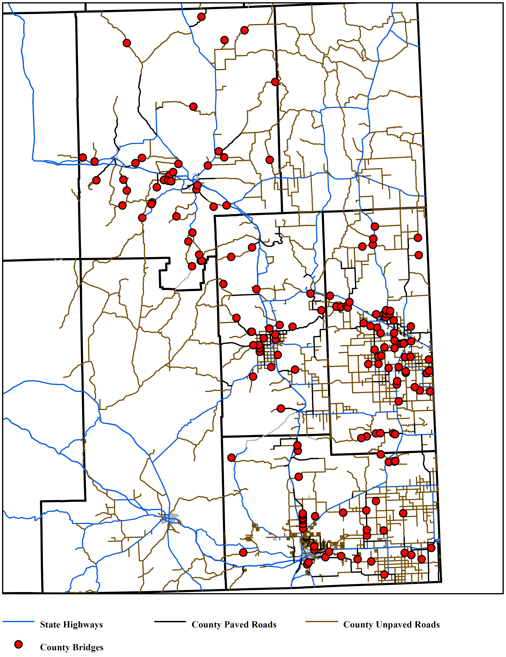

Figure 1 Location of County Bridges in Southeastern Wyoming.

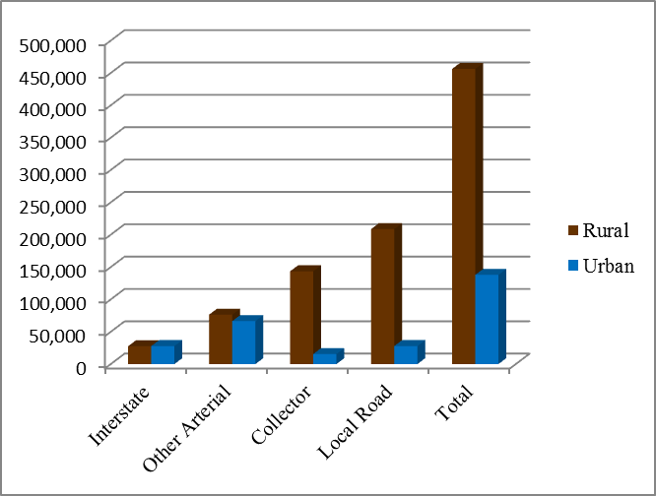

Figure 2 Bridges nationally by roadway classification *(FHWA 2006)*.

Bridges are built to last a long time, but every bridge has a finite service life. Bridges are typically designed to provide 50 years of service, but this period can be extended with rehabilitation and favorable conditions. Figure 3 shows a map of when county bridges were constructed Laramie County.

**Expected Outcomes:**

The findings of this study would provide the following benefits:

* The developed methodology will help local government manage their bridges more effectively.
* The developed methodology will prioritize the replacements of local bridges in the state. The process will insure fairness in allocating resources to bridges in different counties based on the developed systematic criteria.
* The development of minimum standards that would satisfy the needs of the locals and meet state and federal requirements would insure the satisfactions of all parties involved in the process and maximize the benefits to the driving public.

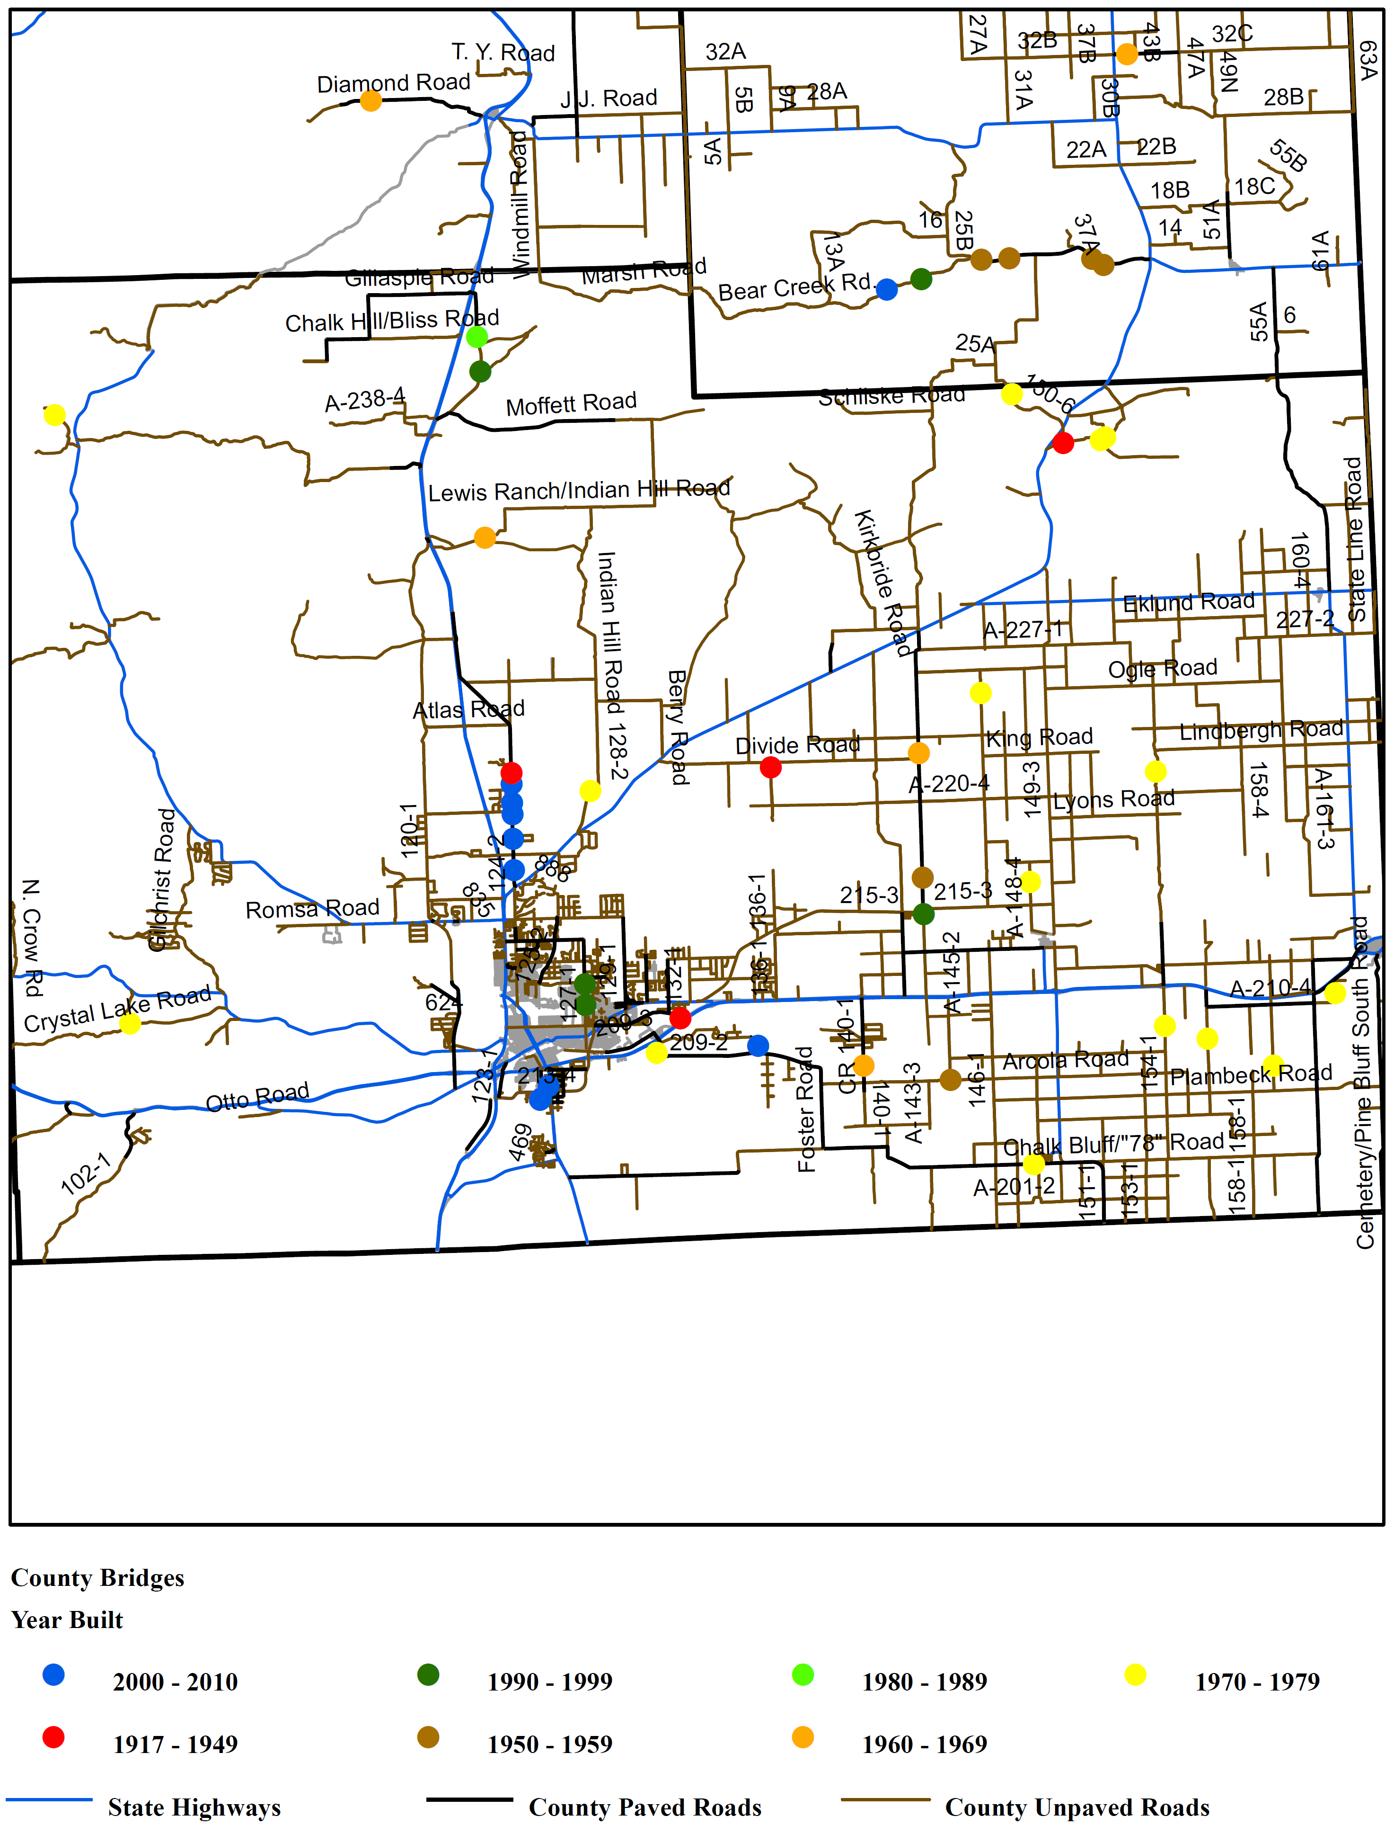

Figure 1 Year Bridges were Constructed in Laramie County

**Relevance to Strategic Goals:**

This proposal is consistent with the State of Good Repair. It is important that local bridges are managed in a cost effective manner so that the available limited resources are utilized effectively.

**Educational Benefits:**

At least one graduate student will be involved in this study.

**Work Plan:**

The following tasks will be performed in this study:

1. Conduct a comprehensive literature review.
2. Develop a methodology for evaluating short span bridges.
3. Obtain information from the WYDOT bridge program on local bridges in the state. This information should include results from bridge inspection reports in addition to any other relevant information on the design features of local bridges.
4. Obtain geometric, traffic, and crash information on all local bridges.
5. Develop a methodology to rank local bridges based on several criteria and factors affecting the performance of local bridges. The core matrix of criteria would include:

* Condition rating from the bridge inspection reports provided by the Wyoming Department of Transportation.
* Risk analysis based on the likelihood of an extreme event and the consequences or impact of failure.
* The environmental requirements as identified by the Department of Environmental Quality.
* Hydraulic and hydrologic requirements for the adequacy of the design.
* Traffic volumes and types.
* Safety concerns as identified by crash data, geometric design of the roadway and other features that need improvements.

1. Apply the developed methodology on all local bridges with poor ranking according to the bridge condition rating.
2. Prioritize bridge replacement based on the results of task 5. This would help in identifying which bridges should be replaced first based on a systematic procedure.
3. Communicate with bridge experts, local governments, WYDOT, and FHWA to adopt realistic minimum standards for local bridges.
4. Prepare a report summarizing the conclusions and recommendations.
5. Present the findings to interested parties such as WYDOT staff, local government officials, WCCA, legislatures, and other transportation professionals.

**Project Cost:**

Total Project Costs: $ 154,105

MPC Funds Requested: $102,092

Matching Funds: $ 52,013 Source of Matching Funds: Wyoming LTAP, UW

**TRB Keywords:**

Bridges, short span, optimization, bridge management, bridge rehabilitation

**References:**

FHWA. 2006. Status of the Nation’s Highways, Bridges, and Transit: Conditions and Performance. Exhibit 2-16, Washington DC: Federal Highway Administration.

FHWA. 2011. National Bridge Inventory (NBI), Count of Bridges by Highway System, Washington DC: Federal Highway Administration.