MPC-432

January 1, 2013- December 31, 2013
Project Title:
Finding Innovative Solutions to Prevent Wildlife Access to Highways at Wildlife Guards

University:
Utah State University

Principal Investigators:
Patricia Cramer, Research Assistant Professor, patricia.cramer@usu.edu, 435-797-1289

Research Needs:
Wildlife entering roadways can become involved in collisions with vehicles, creating a safety hazard for the motoring public and threatening the survival of wildlife populations. This proposal involves creating innovative strategies to keep wildlife off the road while helping them move above and below roads using culverts and bridges. Wildlife-vehicle collisions (WVC) occur over 1.5 million times each year in the United States causing at least $1.1 billion in vehicle damage and killing an average of 200 humans each year (Huijser et al. 2009). The most cost-effective method to prevent WVC is the placement of wildlife crossing structures with wildlife exclusion fencing (8 feet high) (Hedlund et al. 2004). This fencing keeps wildlife off the road and guides them to culverts and bridges designed to facilitate wildlife passage under (or above) the road. These types of fences are also used to keep deer and other wildlife out of restricted areas such as airports and military bases. If local driveways, roads, and entrance and exit ramps that bisect wildlife exclusion fencing are not designed with an effective deterrent to keep deer, elk, moose (ungulates) and other wildlife from entering the road right of way, the wildlife crossings and fencing become ineffective. These vehicle ingress and egress points that cross the wildlife exclusion fencing have to allow vehicles but deter animals, especially those with hooves. Traditional single cattle guards along these entrance points are not wide enough to deter deer and other large animals; they just jump over cattle guards. The standard cattle guard design for deterring wildlife in these areas is to place double cattle guards or similar wide guards embedded in the road. These other guards include wildlife guards which are as wide as double cattle guards and are created in a metal grid pattern. They also include Electromats®, a plastic strip embedded with copper wiring that hold an electrical charge, and placed in the road bed (see Seamans and Helo 2008a, 2008b, Holland-Allen 2011 for efficacy results).

Double cattle guards, wildlife guards, and Electromats® costs increase from approximately $30,000 when placed in narrow roads, to $60,000 for wider roads and highway ramps. Utah Department of Transportation (UDOT) estimates four double cattle guards placed on entrance and exit ramps along an interstates interchange cost $240,000 (R. Taylor, UDOT, personal communication). UDOT is looking for innovative solutions that would allow the placement of a single cattle guard with another device that repelled wildlife as well as a double cattle guard but would cost less. This research will explore different types of technologies that could be added to single cattle guards, wildlife guards, and Electromats® that could further repel animals by possibly acting on their hearing, visual, smell, and other senses. These devices could use electric current, sound, scent, or visual movement that would act to repel approaching animals from trying to jump the single cattle guard. It is important to UDOT, other departments of transportation, airports, and military bases to explore the technology options that could be added to single cattle guards to create a situation that would repel approximately 90% of the ungulates that attempt to enter the roadways at those points, while keeping the cost under that of double cattle guards.

Research Objectives:
This study will monitor wildlife approaches to double cattle guards, wildlife guards, and an Electromat® along Utah roads to determine repel rates for these deterrent devices. The study will investigate technological approaches to add to single cattle guards on similar roads that would be less costly than double cattle guards and yet would repel ungulates at rates comparable to the double cattle guards, wildlife guards, and Electromats®. These technologies would work with electric currents, or scents, or visual deterrents to repel animals that approach, while still allowing vehicles to pass. The technological approaches would be applied through a process that examined the animals’ behavioral reactions to the devices to find which ones worked best. The hypothesis to be tested is that these new technologies applied with single cattle guards can cost-effectively deter mule deer, elk, and moose at rates comparable (within 5%) to double cattle guards. The study would use cameras traps at these guards to evaluate what each animal approach results in, either animals being deterred, or animals crossing over the guard to enter the road right of way.

Research Methods:
Camera traps (remote trail cameras) will be placed at existing double cattle guards, wildlife guard(s), and an Electromat® (from here forward referred to as guards), at various roads and highway ramps in Utah (see Figure 1 for photo from current study). These roads include US 91 near Logan, UTwhere a camera currently monitors a wildlife guard; US 6 near Soldier Summit, UT where two existing double cattle guards will be monitored, I-80 near Park City, UT where new wildlife guards at entrance-exit ramps may be monitored, I-70 at the junction with I-15 in UT where entrance-exit ramps may be monitored; I-15 near Cedar City, UT where wildlife single cattle guards and double cattle guards will be monitored; and US 40 near Heber, UT where an Electromat® will be monitored. Each site will have one to two cameras placed at the guard to monitor ungulate and other wildlife approaches. Bi-monthly cameras will be checked, data will be uploaded from the cameras and batteries changed. Photographs will be analyzed and total number of animals of each species that approach each guard, total number of animals repelled by the guard, and total animals that breach the guard will be tabulated for each guard and each species. This will establish the base rates of repellence for typical guards, and help the researchers understand the components of the guards that are allowing breaches, such as the side strips of cement that mule deer and moose have already been photographed using to access the highway. Cameras will also be placed on single cattle guards in similar wildlife areas to understand what the typical rates of breaches are for these guards.

This project will employ a graduate student who will help design and deploy the different technological approaches to deterring ungulates from single cattle guards as they approach them to enter the road right of way. These technologies will be less costly than a second cattle guard at the site, and placed in a manner to deter theft. These technologies could include the release of a scent, loud sounds, electrical currents, movement of a device, or bright lights to scare the animals off. The devices will be placed at different single cattle guards across the state and tested for efficacy. Camera traps will be placed at these experimental guards to examine ungulate reactions. The rates of deterrence at the new devices will be compared to typical guards to evaluate if the new device with a single cattle guard is a cost-effective option for deterring animals from fenced areas. All cameras and devices would allow vehicles to pass unimpeded.

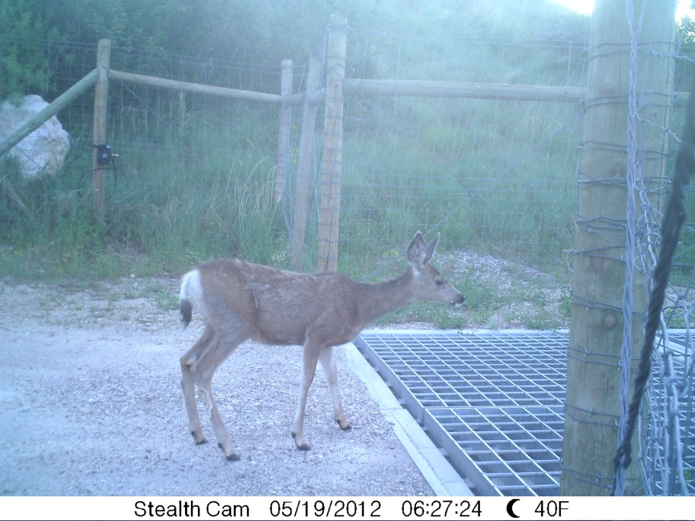
Figure 1. Mule deer evaluates wildlife guard along US 91 near Logan, Utah.

Expected Outcomes:
The research is expected to produce several different methods to repel ungulates and other wildlife from entering a road or other fenced areas at vehicle access points. The final results will include designs for traditional single cattle guards with new devices added to those guards that keep the cost of the combination below that of double cattle guards and deter ungulates at a similar rate. If these new methods prove to be less effective at deterring animals from entering the road right of way than double cattle guards a guide of the full range of options will still be presented. This guide will provide the full range of guard and device options, their rates of deterrence, and costs for practitioners to evaluate which approach would work best for individual situations. Practitioners would be able to apply the new methods to areas with mule deer, elk, and moose where the animals are to be kept out of a road or other areas. There will be tangible products that would include instruction manuals and devices that could be purchased or created with ease.

Relevance to Strategic Goals:
The proposed project and its outcomes are related to Safety Goals; wildlife-vehicle collisions cause loss of life not only to animals but to the motoring public, and this project is designed to help prevent those collisions. The creation of a cost-effective method to deter ungulates from roads would support an Economic Competiveness Goal. If the devices and guards could be designed to deter 90% of the animals that approach them, and these animals could in turn be convinced to use nearby wildlife crossings, the goal of Environmental Sustainability could be partially met.

Educational Benefits:
A mater’s student in the Utah State University department of Wildland Resources will be supported with funds from this research. It is expected the student will receive their master’s of science in wildlife ecology from this work. Results could be shared in Department of Wildland Resources seminars, wildlife management classes, and Utah State University Civil Engineering courses. Dr. Cramer, P.I. for this research has already presented similar work at undergraduate civil engineering courses and could present the results there. The P.I. also presents finding of wildlife and road research each year at the UDOT Engineers’ Conference. The results of this study would be presented at this conference as well, in the form of a talk and a student poster. The master’s student would also submit the study’s results to the International Conference on Ecology and Transportation for a poster or talk.

Work Plan:

Major Tasks/Steps & Completion Dates | Months from Start Date
 | 2 | 4 | 6 | 8 | 10 | 12 | 14 | 16 | 18 | 20 | 22 | 24
1. Recruit Graduate Student 6/13
2. Field work - establish monitoring cameras on existing guards on US 6, I-15, I-170, I-80, US 91 10/13
3. Research & select potential deterrent devices 6/14
4. Purchase, create, mount deterrent devices on single cattle guards 3/14
5. Monitor guards with new devices, also continue to monitor other guards 6/15
6. Analyze pictures to evaluate how well devices work-stage 1 10/14
7. Adaptively Manage study to make changes to devices – Stage 2 12/14
8. Analyze pictures to evaluate changes Stage 3 6/15
9. Statistical analyses 5/15
10. Final Analyses 6/15
11. Remove cameras, end field work 6/15
12. Draft Report 7/15
13. Final Report 8/15
14. Technology Transfer plan – research seminar via the Transportation Learning Network, UDOT Engineers’ Conference 11/14, 11/15

Project Cost:
Total Project Costs: $ 102,936
MPC Funds Requested: $ 50,000
Matching Funds: $ 52,936 Source of Matching Funds: UDOT, Region 4

TRB Keywords:
Wildlife, wildlife crossing structure, wildlife fencing, cattle guard, wildlife guard, Electric mat, Electromat, fencing

References:

Hedlund, J. H., P. C. Curtis, G. Curtis, and A. F. Williams. 2004. Methods to reduce traffic crashes involving deer: what works and what does not. Traffic Injury Prevention, 5: 122-131.

Holland-Allen, T. D. 2011. The use of wildlife underpasses and the barrier effect of wildlife guards for deer and black bear. Master’s Thesis, Montana State University, Bozeman, Montana. 82 pages.

Huijser, M. P., J. W. Duffield, A. P. Clevenger, R. J. Ament, and P. T. McGowen. 2009. Cost–benefit analyses of mitigation measures aimed at reducing collisions with large ungulates in the United States and Canada; a decision support tool. Ecology and Society 14(2): 15. URL: http://www.ecologyandsociety.org/vol14/iss2/art15/

Seamans, T. W. and D. A. Helon. 2008a. Comparison of electrified mats and cattle guards to control White-tailed deer (Odocoileus virgninianus) access through fences. USDA National Wildlife Research Center – Staff Publications. Paper 798. URL: http: //digitalcommons. Unl.edu./icwdm_usdanwrc/798

Seamans, T. W. and D. A Helon. 2008b. Evaluation of an electrified mat as a white-tailed deer (Odocoileus virginianus) barrier. International Journal of Pest Management, 54:89-94. URL: http://dx.doi.org/10.1080/09670870701549624

