MPC-507

March 29, 2016

Project Title
Automating Inspection and Damage Assessment of Transportation Infrastructure with Photographic Imaging

University
Colorado State University

Principal Investigators
Paul Heyliger
Professor
Department of Civil and Environmental Engineering
Colorado State University
Fort Collins, CO 80523
Phone: (970) 491-5048
Email: prh@engr.colostate.edu
Rebecca Atadero
Assistant Professor
Department of Civil and Environmental Engineering
Colorado State University
Fort Collins, CO 80523
Phone: (970) 491-3584
Email: ratadero@engr.colostate.edu

Research Needs
Maintaining safe operating conditions and effectively allocating maintenance resources depends on accurate and timely assessments of transportation infrastructure condition. Visual inspection of transportation structures is limited by a lack of optimal means of quantifying assessments and tracking changes in such assessments over time. Although several branches of inspection are thorough and robust, most rely on somewhat subjective measures that are in the eye of the beholder and accordingly can have significant levels of variation across different inspectors (Moore et. al., 2001). In this work, a more objective method of inspection and assessment is proposed using technology associated with recently developed methodologies known as Structure from Motion (SFM). This technology allows assessments to be made from a sequence of digital photographs from non-specialized, low-cost equipment (Westoby et al., 2012, Koutsodis et al., 2014). This proposal outlines how such a procedure can be used to develop methods of inspection and assessment of environmental degradation or traumatic damage that is more objective and potentially more valuable in prioritizing transportation structures for repair or maintenance.

Research Objectives
The objectives of this study are to 1) develop a method of evaluating the physical consequences of environmental degradation or structural change of transportation structures using conventional photographic images, and 2) explore the feasibility of rapidly automating such a procedure for quantifying levels of damage or degradation, and 3) use these assessments to prioritize resources for repair or remediation.
The primary focus of the initial work is on guard rails, and particularly those that divide medians along the interstate corridors of I-25 and I-70 in Colorado. These are mainly for convenience: they are regularly damaged and repaired during the course of most years (see Figure 1, left), and provide a rich target for analysis and study. However, other damaged structures such as bridges (Figure 1, right) or walls, will also be monitored for possible study.
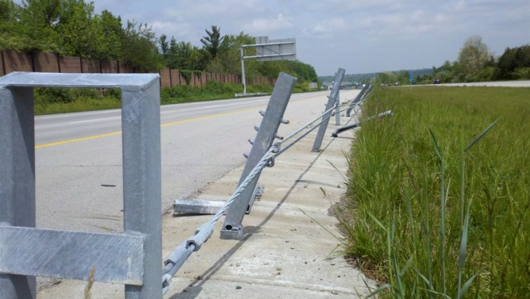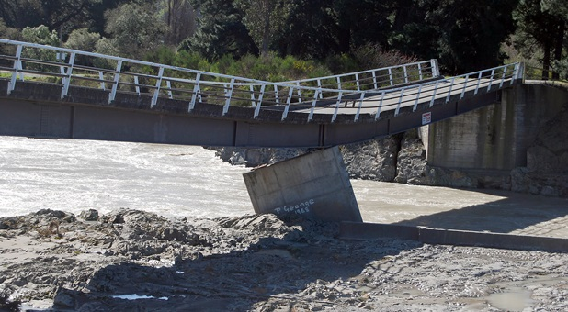
Figure 1. Two examples of damaged transportation structures (guard rails on the left, a flood-damaged bridge on the right) whose residual strength and stiffness can potentially be quantified using standard digital photography when combined with structure-from-motion technology.
Preliminary imaging analysis on the proposed guard rails as shown on the left in Figure 1 proved problematic for two reasons. First, the current imaging technology was deficient in capturing sufficient detail for long and slender elements representing the wire cables of the median barriers suggested for research. Second, it was difficult to ensure the safety of the graduate student who was taking the photographs during the times of optimal sunlight on the median strip: early morning and late afternoon, which coincided with times of high travel along I-25. Attention will be shifted to 1) natural bridges, which possess the benefit of being devoid of traffic and will allow imaging at all times of the day, and 2) a more remote bridge structure where the dimensions of the structure are more consistent in three directions.

Research Methods
Two primary research tools will be used as the underlying research methodology. The first is commercial software based on a field of imaging processing known as Structure from Motion. This tool allows standard digital photographs to be used in recreating digital point clouds that can then be used to determine and record changes in appearance or structure from previously existing levels. The second tool is using these point clouds to construct structural analysis models to determine the predicted level of strength and stiffness after the structure has been changed through either slow degradation or a sudden event such as impact. Images will be collected from several representative tests sites and lab experiments to show how this methodology can provide an additional set of tools for objectively evaluating transportation structures.

Expected Outcomes
The expected outcome of this work is an initial assessment of feasibility of being able to 1) measure and record levels of degradation or damage in typical structures, and 2) determining the costs and benefits of being able to automate such a methodology so that it can potentially be used as an assessment tool at a larger scale. This methodology has not, to the knowledge of the investigators, been used for this sort of purpose.

Relevance to Strategic Goals
This project has the potential to make important contributions to the State of Good Repair goal. A state of good repair can be best achieved when accurate assessments of structural condition are available for decision making. The ability to quantitatively track and document changes over time is also an important contribution because current inspection ratings are of limited utility in developing deterioration models. Such models are important to forecasting future maintenance needs. Accurate assessments of remaining structural capacity are also important to the strategic goal of safety.

Educational Benefits
The proposed study contains two educational elements. First, a graduate student will be funded to perform much of the work, particularly any analysis portion of the research. Second, students in the Honors section of the undergraduate class CIVE 360 (Mechanics of Solids) will be tasked with generating image databanks and typical point clouds for prototype structures. These sophomore level students will thus be directly exposed to research and transportation infrastructure early in their undergraduate careers. These students usually work unfunded as part of their academic requirement for honors credits. Historically, 10-15 students have participated each year. The classes of Spring 2016 and Spring 2017 will both participate if they have interest. Additional funding to support equipment needs is being sought as this proposal was being submitted.

Work Plan
The major tasks associated with this research are as follows:
- Define existing structures that will be assessed.
- Train graduate and undergraduate students in image creation and manipulation. Collect initial images from defined field sites.
- Monitor Colorado roadways for any transportation structures that have seen damage from accidents or other impacts and collect full image data. Develop methods for assigning numerical scores for level of expected damage or degradation.
- Perform post-image analysis on damaged structure to determine the percent of full capacity at which damaged structures can act.
- Complete draft report and possible journal article(s) based on initial work.
A chart with expected time completion dates is shown below.
 | Project Months
 | 1-2 | 3-4 | 5-6 | 7-8 | 9-10 | 11-12 | 13-14 | 15-16 | 17-18 | 19-24
Task 1 | X | X | X
Task 2 |  |  | X | X | X | X
Task 3 |  |  |  |  | X | X | X | X
Task 4 |  |  |  |  | X | X | X | X | X
Task 5 |  |  |  |  |  |  |  | X | X | X

Project Cost
Total Project Costs: $99,482
MPC Funds Requested: $49,741
Matching Funds: $49,741
Source of Matching Funds: Colorado State University

References
Koutsoudis A, Vidmar B, Ioannakis G, Anaoutoglou F, Pavlidis G, and Chamzas C. Multi-image 3D reconstruction data evaluation. Journal of Cultural Heritage 15 pp. 73-79 (2014).
Moore, M., Phares, B. M., Graybeal, B., Rolander, D., & Washer, G. (2001). Reliability of visual inspection for highway bridges, volume I: Final report (No. FHWA-RD-01-020,).
Westoby MJ, Brasington J, Glasser NF, Hambrey MJ, and Reynolds JM. Structure-from-Motion photogrammetry: A low-cost, effective tool for geoscience applications. Geomorphology 179 pp. 300-314 (2012).

