MPC-588

January 12, 2019

Project Title
Hybrid Bridge Bents Using Post-tensioned Precast Columns for Accelerated Bridge Construction in High Seismic Regions

University
University of Utah

Principal Investigators
Chris P. Pantelides
Professor
University of Utah
Phone: (801) 585-3991
Email: c.pantelides@utah.edu
ORCID: 0000-0003-3309-3488

Research Needs
A relatively new philosophy in the design of bridges located in regions of high seismicity seeks to reduce residual displacements in the event of a large earthquake. As an example, Japanese design criteria for bridges have changed after the Kobe earthquake, to require designers to limit permanent drifts to less than 1% (Japan Road Association 2002). The Christchurch earthquake has highlighted difficulties in assessing future performance and repair of damage to plastic hinge zones in conventional reinforced concrete structures (Routledge et al. 2016). Low-damage ductile-jointed systems have been developed to control damage in plastic hinge regions and minimize any residual displacements. These systems provide self-centering capability using un-bonded post-tensioning, and provide energy dissipation through yielding of non-prestressed reinforcement or yielding dampers.
Post-tensioning is a commonly used method for building slender structures that can be constructed rapidly. Precast concrete bridge elements are included in the Accelerated Bridge Construction (ABC) method, which ensures minimum disturbance to commuters and residents at bridge construction sites (Ameli et al. 2016, Ameli and Pantelides 2016). A new hybrid precast concrete bridge bent, capable of self-centering after seismic events and dissipating a sufficient amount of seismic input energy through external dampers (Buckling Restrained Braces or BRBs in this case) is proposed. Two configurations of BRB installation, a diagonal and a chevron arrangement are proposed. The ratio of BRB core area to total post-tensioning (PT) steel area in the two columns will be optimized through a parametric study. Both BRB arrangements will be subjected to historical ground motions to assess the performance of the proposed design.
The concept of hybrid self-centering structural behavior originated from the stepping railway bridge over the South Rangitikei River in New Zealand, where rocking was combined with a hysteretic energy dissipation device. Similar features were provided for an industrial chimney at the Christchurch airport in New Zealand. This innovative idea was applied to concrete moment frame and coupled-wall buildings under the PREcast Seismic Structural Systems (PRESSS) program. Analytical studies were carried out considering potential applications of self-centering to bridge columns.
Large-scale experiments on precast segmental post-tensioned bridge columns were performed which showed that the desired ductility and self-centering could be achieved. Shake table tests of cast-in-place hybrid concrete bridge columns were performed by Mahin et al. (2005). Analytical studies and quasi-static cyclic tests on monolithic, purely rocking, and hybrid concrete columns, developing solutions for energy dissipation have also been carried out (Billington and Yoon 2004, Restrepo et al. 2011). Guerrini (2015) conducted cyclic tests on post-tensioned precast concrete dual shell columns with external energy dissipation devices and successfully achieved self-centering up to a 3% drift ratio. These studies demonstrate that unbonded post-tensioning can be used to achieve self-centering of structures if yielding of post-tensioned bars could be prevented.
As far as BRB components, previous numerical and experimental studies showed that BRBs installed in a bridge bent help the structure dissipate seismic energy, and improve the seismic performance of the bridge in the transverse direction. BRBs have also been proposed to increase the seismic capacity of bridge decks in the longitudinal direction.

Research Objectives
This proposal will investigate an innovative self-centering multi-column bridge bent system with precast concrete columns for Accelerated Bridge Construction (ABC) in high seismic regions. The proposed hybrid system consists of post-tensioned precast concrete columns in a two-column bridge bent with one or two Buckling Restrained Braces (BRBs) as external supplementary energy dissipation devices. In this manner it is expected that the precast columns will be repairable in strong earthquakes. Two configurations of BRBs are considered: two BRBs in a chevron arrangement and one BRB in a diagonal arrangement. The BRB devices could be replaced after a severe earthquake whereas the gravity load bearing frame should remain undamaged. Large inelastic rotations are accommodated due to gap opening at the rocking planes without damage to the column concrete. Post-tensioned high-strength threaded steel bars, designed to stay elastic ensure self-centering of the columns.
The objectives of this project are:
- Test under cyclic loads alternative methods for constructing bridge bents in high seismic regions using self-centering in terms of post-tensioning of bridge columns and BRBs as external supplementary energy dissipation devices.
- Develop analytical models for self-centering in terms of post-tensioning of columns in bridge bents with external BRBs, to assist in the design and implementation of such bridges.
- Present the results at national conferences and journal publications.

Research Methods
The proposed research will evaluate the seismic performance of bridge bents constructed with ABC methods under simulated earthquake loads. The research will be performed by conducting half-scale experiments of prototype bridge bents constructed using post-tensioned columns with one or two BRBs. Analytical models will be developed for implementing the two bridge systems using OpenSees (McKenna et al. 2000).

Expected Outcomes
The proposed research will provide an innovative method to construct bridge bents using ABC in high seismic regions. In particular, self-centering in terms of post-tensioning of bridge columns combined with Buckling Restrained Braces (BRBs) as external supplementary energy dissipation devices will be investigated. Analytical models will be developed including design recommendations for implementing the proposed system using OpenSees (McKenna et al. 2000) and will be compared to experimental results from the half-scale experiments to be carried out in this project. It is expected that the research will result in bridges with repairable precast columns for high seismic regions.

Relevance to Strategic Goals
Seismic resilience of bridges improves safety and livability of communities. The State of Utah is likely to experience a strong earthquake in the next 50 years. Successful completion of the proposed project will ensure that this innovative method of constructing bridges will improve seismic resilience of the bridge inventory for strong earthquake events. The experiments to be carried out in this project will validate the proposed concept.

Educational Benefits
At least two university students will be involved in the project. One PhD student will be involved in the experimental and analytical portion of the work. One undergraduate student will be funded from the Office of Undergraduate Research Opportunities program at the University of Utah. The technology transfer activity will involve high school students through an Annual Exploring Engineering Camp, during which small-scale models will be built to show details of the bridge bents. In addition, small-scale models will be constructed by students during a mini-engineering day. The P.I. will make a presentation at the annual UDOT Engineering Conference and at other national conferences including the Annual AASHTO Subcommittee on Bridges and Structures Meetings and the Annual Transportation Research Board Meeting.

Technology Transfer
The main objective of this research is to create an alternative for the accelerated construction of bridges in seismic regions using self-centering in terms of post-tensioning of columns of a bridge bent with one or two BRBs as external supplementary energy dissipation devices. There is a need for developing such innovative technology and the proposal addresses that need. The resulting technology will produce bridges that are seismically resilient, sustainable and economical. The work will be presented at leading conferences on this topic such as the Transportation Research Board Meeting and leading journals such as the Journal of Bridge Engineering, ASCE. In addition, a webinar will be arranged through the Mountain-Plains Consortium and a presentation will be made at the Utah Department of Transportation Annual Conference.

Work Plan
The proposed study will consist of the following tasks:
Task 1. Build two half-scale bridge bents
Two bridge bents will be built with the general details of a prototype bridge bent with two BRBs (chevron arrangement) or one BRB (diagonal arrangement), as shown in Fig. 1. The actual bridge bent dimensions and reinforcement to be tested are based on a scaled model of the bents of the Riverdale Road Bridge over I-84 in Riverdale, Utah (UDOT 2008). The tests will be carried out at the University of Utah Structures Laboratory. The concrete will have a compressive strength of 6,000 psi and the steel reinforcement will have a tensile yield strength of 60,000 psi. The columns will be 8 ft-3 in. long with an octagonal cross-section 18 in. thick. The cap beam will be 14 ft–2 in. long with a 22 in. x 20 in. cross-section. The axial load will be 100 kips at each column. The two footings will have a dimension of 6 ft x 3 ft x 20 in. as shown in Fig. 1. The lateral drift history will consist of increasing amplitudes of the predicted column yield drift ratio; two cycles will be employed for each drift ratio step to the east and west (ACI Committee 374 2013). This activity should be completed in three months.
Task 2. Perform seismic tests of bridge bents
The bridge bent system proposed in this research has the overall dimensions shown in Fig. 1. In this task the reinforcement and details of the columns of the bent are described. The bridge bent will have two columns with post-tensioned bars with additional mild steel, as shown in Fig. 2. The main reinforcement details include two 1 in. post-tensioning (PT) bars located as shown in Fig. 2 that are unbonded. The post-tensioning bars are made of Grade 150 steel and are anchored in the footing and post-tensioned at the top of the cap beam. The mild steel does not cross the column to footing and column to cap beam interface. The mild steel rebar within the column consists of 12#4 bars. The steel spiral reinforcement consists of #3 diameter steel bar at a 2.5 in. pitch, as shown in Fig. 2.
There is a need to balance the self-centering forces (gravity and post-tensioning) and the energy dissipating forces. In order to ensure self-centering behavior, gravity and post-tensioning forces must be large enough to overcome the overstrength capacity of the energy dissipating forces. The following upper bound for the re-centering coefficient Λ_{C} has been proposed (Guerrini et al. 2015):
${ Λ}_{C}=\frac{F_{ED}}{P_{u}+F_{PT}}≤$0.6 (1)
where F_{ED} is the ultimate energy dissipation force from mild steel, which in the present case is the BRB, P_{u} is the gravity force, and F_{PT} is the effective posttensioning force. The limit of 0.6 is suggested to account for uncertainty on post-tensioning losses and the presence of debris from gap opening in the rocking interfaces. On the other hand, enough energy dissipation should be provided to the system to avoid the large scatter on lateral displacement demands observed on purely rocking systems, in which additional energy is lost due to plastic deformation at the contact points (Makris and Roussos 1998). The following energy dissipation coefficient has been proposed (Guerrini et al. 2015):
${ Λ}_{D}=\frac{F_{ED}}{P_{u}+F_{PT}+F_{ED}}≥$0.1 (2)
In this study, Λ_{C} based on the design shown in Fig. 2 is evaluated as follows: F_{PT} = 2*0.85*90 = 153 kips; F_{ED} = 100 kips (assumed); P_{u} = 100 kips; Λ_{C} =100/(100+153) = 0.40 < 0.6. Also Λ_{D} is equal to Λ_{D} =100/(100+153+100) = 0.28 > 0.1. This activity should be completed in three months.
(a) (b)
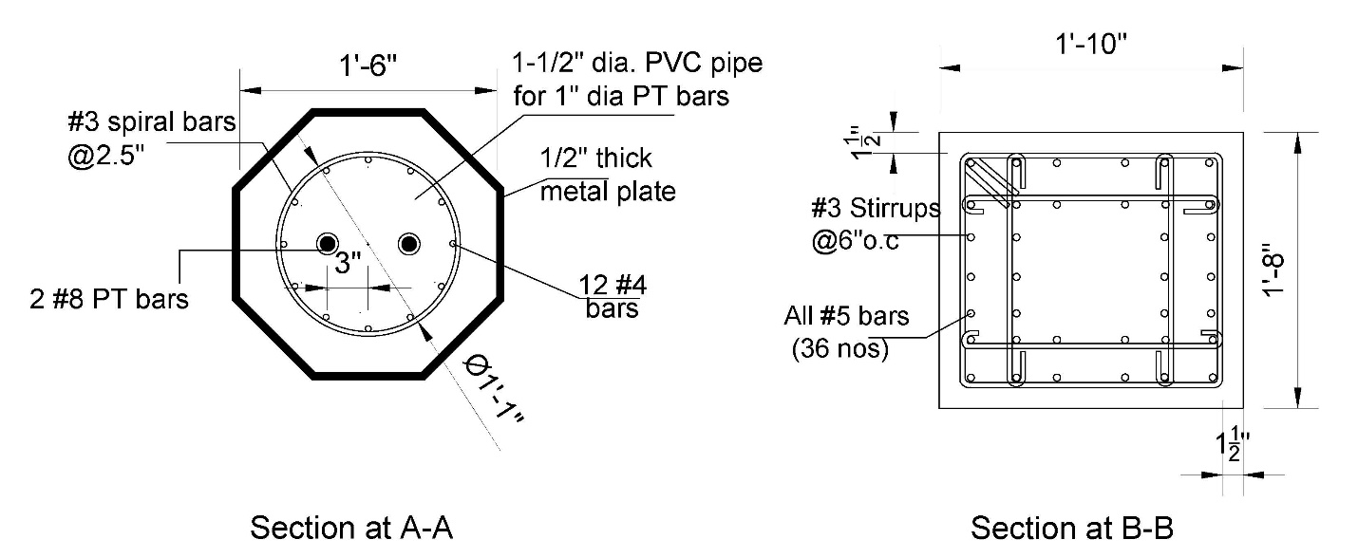
Figure 1. Proposed design of self-centering energy dissipating hybrid bent with: (a) chevron,
(b) diagonal arrangement of BRBs.
Figure 2. Column details.
Task 3. Analysis and seismic design of bridge bent
In this task, a numerical model will be created to assist in the development of a design method for implementing the proposed bridge bent. Firstly, the model will be calibrated with the results of the test presented in Task 2. Secondly, the model will be used to study two full-scale bridge bents, including the Riverdale Bridge and an alternative, similar to the post-tensioned bridge with the details of Figs. 1(a) and (b), and Fig. 2. This activity should be completed in six months.
3.1 Analytical Model of Experiment
The model of the bent with post-tensioned bars, precast columns and BRB for the specimen of Fig. 1(b) is shown in Fig. 3. The columns are modeled with nonlinear beam-column elements with a fiber cross-section representing a circular section. The radius of the circular section is calculated using an area equivalent to the octagonal section. High-strength PT bars are modeled using “Steel02” material model and corotational truss elements in OpenSees (McKenna 2010).
The rocking behavior of the column is simulated by modeling a series of zero length, uniaxial, compression-only springs at the base of the column. The rocking plane is modeled with elastic rigid elements connecting the main and slave nodes. At the rocking plane, the gross column cross-section is discretized radially and circumferentially and springs are assigned inelastic material properties using concrete04 uniaxial material model. The unbonded mild-steel reinforcement for energy dissipation is modeled separately from the column fiber section using corotational truss elements fixed at the bottom and top of the unbonded length. The cap beam is modeled with elastic beam-column elements. Initial tension in the PT bars of the post-tensioned columns (Fig. 2) is simulated using the “InitialStress” command; an equivalent vertical load is assigned at the top anchor of the PT bars.
The analytical model will be developed in the OpenSees framework (McKenna et al. 2000; McKenna et al. 2010). A local response criterion which is fracture of reinforcing bars due to low-cycle fatigue will be included in the model as an indication of ultimate displacement capacity.
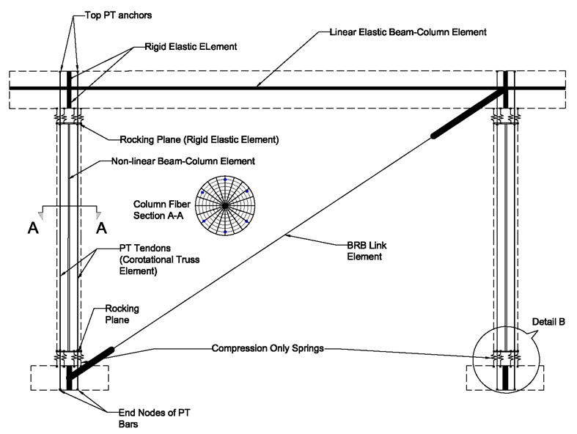
Figure 3. OpenSees model for bent with PT bars and BRB.
The Buckling Restrained Brace (BRB) member will be modeled using a two-node link element with “Steel02” using the Giuffré-Menegotto-Pinto with isotropic strain hardening material model available in OpenSees. The BRB analysis model will be validated against a BRB test carried out by Xu and Pantelides (2017) at the University of Utah.
3.2 Analytical Model of Full-scale Bents
The analytical models developed and verified with the half-scale experiment will be used to study the predicted performance of two full-scale bridge bents, including the Riverdale Bridge and the alternative similar to the post-tensioned bridge with the details of Figs. 1(a) and (b), and Fig. 2. The two models, designated as Type 1 and 2, will have the following details:
Type 1: For the Riverdale Bridge, the typical two-column bent with post-tensioned columns with typical dimensions is shown in Fig. 4. The cap beam has a typical span of 42 ft and the columns a typical clear height of 16 ft. The columns shown in Fig. 4 are 42 in. octagonal with six 1 3/8 in. diameter PT bars. In addition, they are reinforced with 12#6 mild steel bars that do not cross into the footing or cap beam. Details of the cap beam and footing steel reinforcement will be obtained from the original construction drawings of the Riverdale Bridge (UDOT 2008).
Analysis of the full-scale bent of the Riverdale Bridge will follow the models developed for the Post-tensioned Bent.
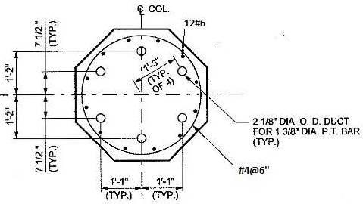
Figure 4. Typical Riverdale Bridge Post-tensioned Bent.
Type 2: For the full-scale bent simulating the Post-tensioned Bent similar to the scaled model of Figs. 1(a) and (b), and Fig. 2, the two-column bent dimensions of Fig. 4 will be used. The only difference with the Type 1 model is that the 12#6 mild steel bares will continue into the cap beam and footing using the grouted ducts, which will be scaled up for the full-scale bridge model.
Two types of analysis will be performed for the two bent types: (1) static cyclic analysis to find the capacity of the system, and (2) nonlinear time-history analysis to find the level of demand on the bridge bents. This will provide information on capacity-demand relationships for the two bridge bent alternatives, and will reveal more insight into the overall behavior of the two bents under various input ground motions.

Project Cost
Total Project Costs: $236,090
MPC Funds Requested: $112,000
Matching Funds: $124,090
Source of Matching Funds: Splice Sleeve North America, US Endowment for Forestry and Communities, Corebrace

References
Ameli, M.J., Brown, D.N., Parks, J.E., and Pantelides, C.P. (2016). “Seismic column-to-footing connections using grouted splice sleeves.” ACI Structural J., May-Jun., 113(5), 1021-1030.
Ameli, M.J., and Pantelides, C.P. (2016). “Seismic analysis of precast concrete bridge columns connected with grouted splice sleeve connectors.” J. Structural Engineering, ASCE, 10.1061/(ASCE)ST.1943-541X.0001678, 04016176.
American Concrete Institute (ACI). (2013). “Guide for Testing Reinforced Concrete Structural Elements Under Slowly Applied Simulated Seismic Loads.” ACI 374, Farmington Hills, MI.
Billington, S. L., and Yoon, J. K. (2004). “Cyclic response of unbonded posttentioned precast columns with ductile ﬁber-reinforced concrete.” J. Bridge Eng., 10.1061/(ASCE)1084-0702(2004)9:4(353), 353–363.
Guerrini, G., Restrepo, J. I., Massari, M. A., and Vervelidis, A. (2015). “Seismic behavior of post-tensioned self-centering precast concrete dual-shell steel columns.” J. Structural Eng., 141(4), 10.1061/(ASCE)ST.1943-541X.0001054.
Japan Road Association (2002). “Design Specifications of Highway Bridges. Part V: Seismic Design.” Japan.
Mahin, S. A., Sakai, J., Jeong, H., Espinoza, A., Hachem, M. M., and Buckman, B. (2005). “Shake table and analytical investigations of single column bents.” Proc., Caltrans Bridge Research Conf., California Transportation Foundation, Sacramento, CA, and California Dept. of Transportation, Los Angeles, Paper 01-501.
Makris, N., and Roussos, Y. (1998). ‘‘Rocking response and overturning of equipment under horizontal pulse-type motions.” Rep. No PEER 1998/05, Pacific Earthquake Engineering Research Center, Berkeley, CA.
McKenna, F., Fenves, G., and Scott, M. (2000). “Open System for Earthquake Engineering Simulation (OpenSees).” Univ. of California, Berkeley, CA. (http://opensees.berkeley.edu).
McKenna, F., Scott, M., and Fenves, G. (2010). “Nonlinear Finite-Element Analysis Software Architecture Using Object Composition.” J. Comput. Civ. Eng., 10.1061/ (ASCE) CP.1943-5487.0000002, 95–107.
Restrepo, J., Matsumoto, E., and Tobolski, M. (2011). “Development of precast bent cap systems for seismic regions.” NCHRP Rep. 681, National Cooperative Highway Research Program, Transportation Research Board, Washington, DC.
Routledge, P. J., Cowan, M. J., and Palermo, A. (2016). “Low-damage detailing for bridges – A case study of Wigram-Magdala Bridge.” 2016 New Zealand Society for Earthquake Engineering, http://confer.co.nz/nzsee2016/.
UDOT (Utah Department of Transportation). (2008). “Dwg. No. C-966.” Riverdale Road Bridge I-15 to Washington Boulevard, Riverdale, Utah.
Xu, W., and Pantelides, C. P. (2017). “Strong-axis and weak-axis buckling and local bulging of buckling-restrained braces with prismatic core plates.” Eng. Struct., 153(2017), 279-289.

