MPC-652

May 7, 2021

Project Title
Reducing Shrinkage Cracking in Bridge Decks Using the Single and Double-Ring Test Methods

University
University of Wyoming

Principal Investigators
Jennifer Tanner, Ph.D.
Associate Professor
Dept. of Civil and Architectural Engineering and Construction Management
University of Wyoming
Phone: (307) 766-2073
Email: tannerj@uwyo.edu
ORCID: 0000-0003-2433-2897

Research Needs
The condition of concrete on bridge decks is one of the most costly parts of Wyoming Department of Transportation’s (WYDOT) budget and the cost of maintenance can result in inadequate roads or costly premature repairs. This proposal evaluates critical factors relating to early age shrinkage and proposes combining multiple mitigation methods to reduce early-age cracking that contributes to early degradation.

Research Objectives
- Evaluate the time to shrinkage cracking and corresponding strains of control concrete mixtures and mixtures with single mitigation methods.
- Evaluate time to shrinkage cracking and corresponding strains of two mitigation methods.
- Quantify the effect of cooler than average temperatures using the double-ring shrinkage test method for the most promising combination of mitigation mixtures.

Research Methods
One of the most limiting factors in in resilient road and bridge design is creating durable concrete. There is currently a lack of agreement regarding early-age damage based on concrete shrinkage. This is attributed to different types of shrinkage: chemical, autogenous, and drying. Some of the different methods used to evaluate restrained shrinkage include free-shrinkage tests (ASTM C157), a shrinkage ring (ASTM C1581), various types of molds with flared ends, bonded overlays, and field test slabs [1]. European work has used a restrained shrinkage specimen with flared ends and this has been adopted by other researchers in the US [2]. Alternatively, a double shrinkage ring has been adopted that permits changes in temperature and humidity levels [3]. Of the different methods, the shrinkage ring specimens are most conducive to laboratory studies because of their smaller size and relatively smaller cost. Furthermore, different temperatures and relative humidity levels can be evaluated using an environmental chamber. The PI has developed one that is currently in use.
A set of two AASHTO 334 single-ring shrinkage test apparatuses will be constructed. One is funded by this project and the other by a companion matching project sponsored by WYDOT. The ring is outfitted with strain gages to measure stresses generated during curing. Three inches of concrete are cast around this ring and the external portion is sealed allowing moisture to leave from the top and bottom of the ring. This test method is typically used to evaluate mortar, however, this project would use up to 3/8” aggregate to evaluate the interface between cement paste and coarse aggregate as well as the stiffening effect of the coarse aggregate.
On the other hand, ASTM T363 permits the evaluation of early age behavior subject to both shrinkage and expansion by using Invar, a material with a low thermal expansion. It is combined with chilling and heating mechanisms to better approximate field conditions, in particular in climates with larger thermal swings.
Starting with WYDOT’s typical design mixture using a stiffer coarse aggregate such as granite and a second using limestone aggregate. This project would compare results to a detailed study conducted by Caltrans and quantify the beneficial effects of using fibers, shrinkage reducing admixtures, and delay the time to cracking. Once this delay is determined, fibers and shrinkage admixtures would be combined to delay cracking thus permitting the concrete to gain sufficient tensile resistance sufficient to reduce early-age cracking.
Another advantage to using the ring is the opportunity to evaluate autogenous shrinkage and effects of early-age moisture loss. As water is lost and shrinkage occurs, internal stresses are generated (Figure 1). When the stresses exceed the tensile strength, the first crack occurs causing a drop in strain and internal stresses. Without mitigation measures, the stresses decrease by roughly 90% as illustrated in Figure 1b. However as fibers are added, cracking width decreases. With sufficient fibers, the stress drop is reduced by only 25%. For example, Shaw and Weiss found that a 0.5% use of steel fibers was effective, however, using smaller ratios such as 0.06% did not reduce shrinkage stress using the ring method [4].
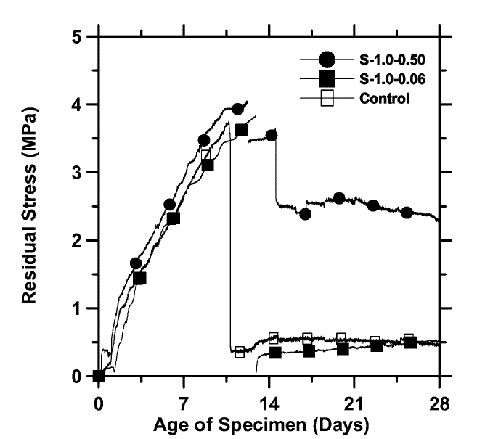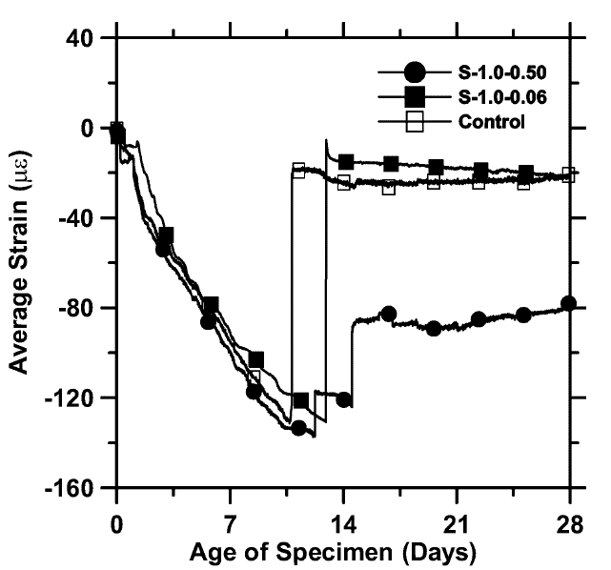
Figure 1. Strain and corresponding residual stresses in shrinkage ring test results. Effective fiber use illustrated by data set with circle markers [4].
Because fibers increase tensile strength, the resistance to cracking also increases with curing time. The type of fibers is also very important; polypropylene fibers have slightly more shrinkage than steel fibers, thus larger volume is required to match the effects of steel fibers [5, 6]. Despite this fact, macro- and micro-polypropylene fibers are proposed to avoid the risk of corrosion with steel fibers. Another benefit to adding fiber is a more distributed cracking pattern [4, 7]. This is helpful because the crack size is smaller and the harmful effects of cracking are reduced.
A second method to reduce cracking is using shrinkage reducing admixtures or expansive cement. This mitigation method delays the occurrence of cracking. By delaying the action, the concrete has more time to gain strength. As reported in other studies, applying multiple mitigation measures is more effective than just a single measure [8]. Testing using a shrinkage ring could be modified to accommodate different construction practices such as covering the concrete or adjusting the relative humidity by placing specimens in an environmental chamber. Such methods will be added to the use of fibers and use of SRAs.
A third method to improve the quality of concrete on bridge decks includes using methods of internal curing to reduce cracking. Concrete will continue to cure if saturated lightweight fine aggregates are used within concrete mixtures. As the effects of drying cause internal shrinkage, the additional water in the fine aggregate is slowly released into the paste. This longer-term method decreases the negative effects of drying and slows down the time to first cracking [9, 10]. Because combined effects will create the most significant effect, the majority of testing is focused on combined solutions that WYDOT can use when specifying concrete design mixtures. The incremental cost of adding SRA and fibers is approximately $25 per cubic yard for each method [11]. Although there is little information available on the cost of internal curing, incrementally it is anticipated to be even less than the previous two methods.

Expected Outcomes
This work is expected to produce more durable concrete and reduce the service life of concrete. In addition, required maintenance will be reduced and the time between maintenance will be extended. Finally, overlays may be eliminated or the time between them will be extended, resulting in safer roads and reduced maintenance costs.

Relevance to Strategic Goals
This project falls within the strategic goal of keeping roads in a state of good repair. More durable concrete with extended service lives, will ultimately reduce the cost of maintaining roads. A secondary area is economic competitiveness because there will be a net savings in construction and maintenance.
As an example of maintenance costs, a single 6,000 ft² bridge deck can reach up to $250,000. This considers two rigid overlays and one epoxy overlay with a 10% class II-A and 5% class II-B repairs. These costs do not include the traffic control and safety mobilization that can add another $100,000 to this single hypothetical bridge deck. If overlays can be deferred or eliminated by reducing or eliminating early age shrinkage cracking, this could result in a significant savings for WYDOT.

Educational Benefits
Results from this project will be supplied to WYDOT in terms of a final report and recommended concrete mixtures. The PI is willing to attend WYDOT training sessions to educate field engineers on results of this study.

Technology Transfer
Results will be published in a final report and in appropriate engineering journals. Results will be made available upon reasonable request to the PI.

Work Plan
This research program focuses on using shrinkage rings to compare and contrast results for selected shrinkage reducing variables. Once data is available for single mitigation strategies, a combination of two or more methods will be proposed to evaluate how much more resilient concrete can become.
Task 1a – Synthesize results of fiber studies using either of these two methods in a form of a database of existing mitigation measures and effectiveness. This data is not readily available in the literature and will provide guidance on what variables need to be evaluated.
Task 1b – Update existing WYDOT testing single ring equipment and perform preliminary testing to evaluate the upper and lower bounds based on results determined for Task 1a.
Task 1c – Construct an AASHTO T363 dual ring system to measure early age shrinkage or expansion based on temperature swings in Wyoming.
Task 2 – Based on results of Task 1b and 1c complete a limited set of single variable studies to quantify the effects of each type of mitigation for two common types of aggregates in Wyoming.
One aggregate will be a stiffer coarse aggregate such as granite and other will be a limestone because it is relatively softer. Modifying single variables includes: using varying dosages of shrinkage reducing admixture to recommend a minimum dosage; using different ratios of micro- and macro-fibers to decrease early age cracking; blended or expansive cements; and internal curing methods. A minimum of 4 variations for each of the combinations are proposed with an additional 3 for the most promising two methods. Results of this study would be compared to shrinkage limits in high performance concrete [14].

Project Cost
Total Project Costs: $ 163,690
MPC Funds Requested: $ 45,999
Matching Funds: $ 117,691
Source of Matching Funds: Wyoming Department of Transportation

References
- Banthia, N. and R. Gupta, Influence of polypropylene fiber geometry on plastic shrinkage cracking in concrete. Cement and Concrete Research, 2006. 36(7): p. 1263-1267.
- Byard, B.E., et al., Cracking Tendency of Bridge Deck Concrete. Transportation Research Record, 2010. 2164(1): p. 122-131.
- Schlitter, J., et al., A Dual Concentric Ring Test for Evaluating Residual Stress Development due to Restrained Volume Change. Journal of ASTM International, 2010. 7(9): p. 1-13.
- Shah, H. and J. Weiss, Quantifying shrinkage cracking in fiber reinforced concrete using the ring test. Materials and structures, 2006. 39(9): p. 887.
- Yousefieh, N., et al., Influence of fibers on drying shrinkage in restrained concrete. Construction and Building Materials, 2017. 148: p. 833-845.
- Afroughsabet, V., L. Biolzi, and P.J.M. Monteiro, The effect of steel and polypropylene fibers on the chloride diffusivity and drying shrinkage of high-strength concrete. Composites Part B: Engineering, 2018. 139: p. 84-96.
- Sadiqul Islam, G.M. and S.D. Gupta, Evaluating plastic shrinkage and permeability of polypropylene fiber reinforced concrete. International Journal of Sustainable Built Environment, 2016. 5(2): p. 345-354.
- Gong, J., W. Zeng, and W. Zhang, Influence of shrinkage-reducing agent and polypropylene fiber on shrinkage of ceramsite concrete. Construction and Building Materials, 2018. 159: p. 155-163.
- Bentz, D.P., P. Lura, and J.W. Roberts, Mixture proportioning for internal curing. Concrete international, 2005. 27(2): p. 35-40.
- Henkensiefken, R., et al., Plastic shrinkage cracking in internally cured mixtures made with pre-wetted lightweight aggregate. Concrete international, 2010. 32(2): p. 49-54.
- Maggenti, R., C. Knapp, and S. Fereira, Controlling shrinkage cracking. Concr. Int, 2013. 35: p. 36-41.

