MPC-663

August 24, 2021

Project Title
Impacts of Vehicle Fires on Polymer Concrete Bridge Deck Overlays

University
Utah State University

Principal Investigators
Shua Ni, Ph.D.
Assistant Professor
Dept. of Civil and Environmental Engineering
Utah State University
Phone: (435) 797-0990
Email: shunani@usu.edu
ORCID: 0000-0002-8795-176X

Andrew Sorensen, Ph.D.
Assistant Professor
Dept. of Civil and Environmental Engineering
Utah State University
Phone: (435) 797-6377
Email: andrew.sorensen@usu.edu
ORCID: 0000-0001-9998-2021

Research Needs
There were 223,000 vehicle fires in the United States in 2019, of which 189,500 occurred on highways [1]. Such a fire can generate heat upward of 1500 °F [2], and emit flames more than 10 feet long. Their high temperatures can cause various levels of damage to highway infrastructure, resulting in further interruption to the transportation network. For example, a vehicle fire resulting from a truck collision on the Brent Spence Bridge on November 11, 2020 damaged the bridge’s decks, support beams, and electrical and drainage systems, leading it to be closed for more than one month [3].
Non-conventional materials that incorporate polymers (e.g., polymer concrete (PC), and polymer-modified concrete (PMC)) are increasingly used in highway-infrastructure construction and maintenance. For example, polymer concrete that consists of aggregate with a polymer binder and contains no Portland cement or water, has high acidity, salt and freeze-thaw resistance, high chemical stability under corrosive environment, high compressive strength, high resistance to water permeation, low shrinkage, and shows its maximum strength at a short period of time [4]. The combination of these characteristics makes polymer concretes an attractive choice in overlays for existing or new bridges, as shown in Figure 1. By 2016, more than 50 bridges have been protected by PC overlays in Utah [5]. Four main types of polymer concrete are used in overlays: epoxy polymer concrete, epoxy urethane polymer concrete, polyester polymer concrete, and methacrylate polymer concrete [5]. Polymers in these concretes are sensitive to high temperatures, with relatively low glass transition temperatures and melting points [4]. For example, polyethylene terephthalate (one type of polyester) exhibits a glass transition between 153 °F to 178 °F and melts at 500 °F [6] [7]. Poly (methyl methacrylate) exhibits a glass transition around 221 °F and melts around 320 °F [8]. The high sensitivity of these materials to elevated temperatures has led to the concern that a vehicle fire may degrade or even completely destroy a PC overlay on a bridge deck.
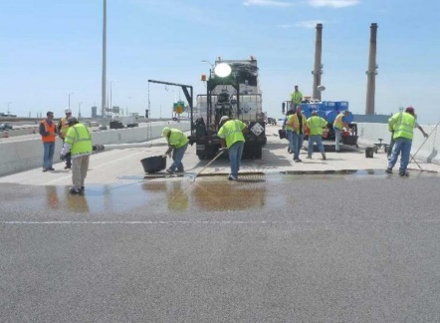
Figure 1 Overlaying concrete bridge deck with polymer concrete [9]
Some further concerns also attend the use of PC as overlays on bridge decks. Among those concerns is the deformation incompatibility of those materials and their concrete substrate at high temperatures. The thickness of a PC overlay is small, usually applied at a total thickness of 0.5-0.75 inches [10]. Under a vehicle fire, a PC overlay will be exposed to high temperature directly while the temperature of the concrete substrate beneath it is still relatively low, as shown in Figure 2. Such a thermal gradient along the bridge deck may lead to the delamination of the overlay from its concrete substrate. This will be further aggravated by the significant difference between the thermal expansion coefficient of PC and that of conventional cement concrete. The thermal expansion coefficient of PC is typically two to three times higher than that of conventional cement concrete [11], [12].
Some prior research has looked at the potential negative impacts of the significant difference between the thermal expansion coefficient of PC and that of concrete substrate [12], [13]. However, most of the existing studies focus on a daily ambient temperature range, and relatively uniform temperature increases or decreases. We have little firm information about scenarios in which a composite panel of conventional cement concrete substrate and PC overlays (hereafter, a “composite panel”) is directly exposed to a vehicle fire, since 1) the heat from a vehicle fire is much higher than the ambient-temperature changes studied to date, and 2) the composite panel experiences thermal gradients not only along its thickness (as illustrated by the vertical red arrow in Figure 2), but also along its surface (the horizontal red arrow) due to the low thermal conductivity of materials and the non-uniform heat exposure of a surface under a vehicle fire. As previously discussed, the strong thermal gradients along a composite panel’s thickness may increase the thermal-expansion difference between the PC materials and their concrete substrates. Such gradients along a panel surface, on the other hand, may result in the area of overlay directly exposed to a vehicle fire expanding against the surrounding cooler areas and thus damaging them.
Accordingly, this project will give due attention to the potential problems that intense heat from vehicle fires may cause to PC bridge deck overlays.
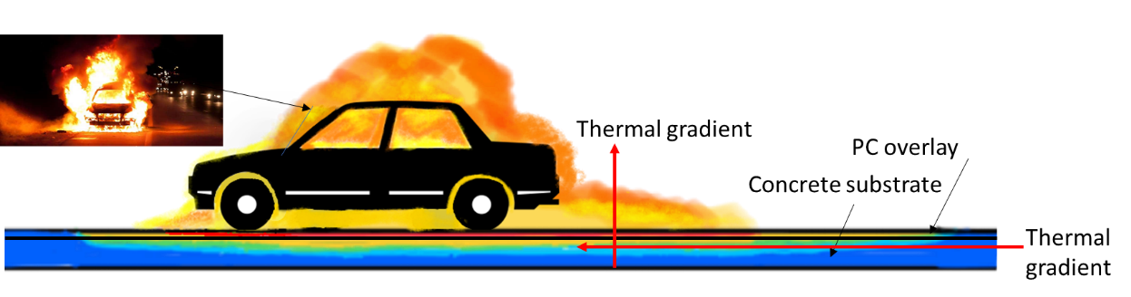
Figure 2 Thermal gradient of a bridge deck under a vehicle fire

Research Objectives
The overall objective of this project is to enhance the vehicle-fire resistance of PC bridge deck overlays. The specific research objectives are:
Objective 1: To identify the impact of vehicle fires on PC bridge deck overlays.
Objective 2: To develop effective preventive design/construction methods and post-fire repair strategies for PC bridge deck overlays.

Research Methods
The majority of this project will consist of experimental tests. As shown in Figure 3, Objective 1 will be achieved through 1) a real vehicle-fire test on a large reinforced concrete (RC) panel protected by a PC overlay; and 2) overlay-performance tests, before and after the vehicle-fire test. Objective 2 will be achieved through 1) suggestions for effective preventive design/construction methods and post-fire repair strategies, based on analysis of the test data; and 2) validation of those suggestions through controlled heating-cooling tests on medium-sized RC panels protected by PC overlays. Further details of these research methods are provided below.
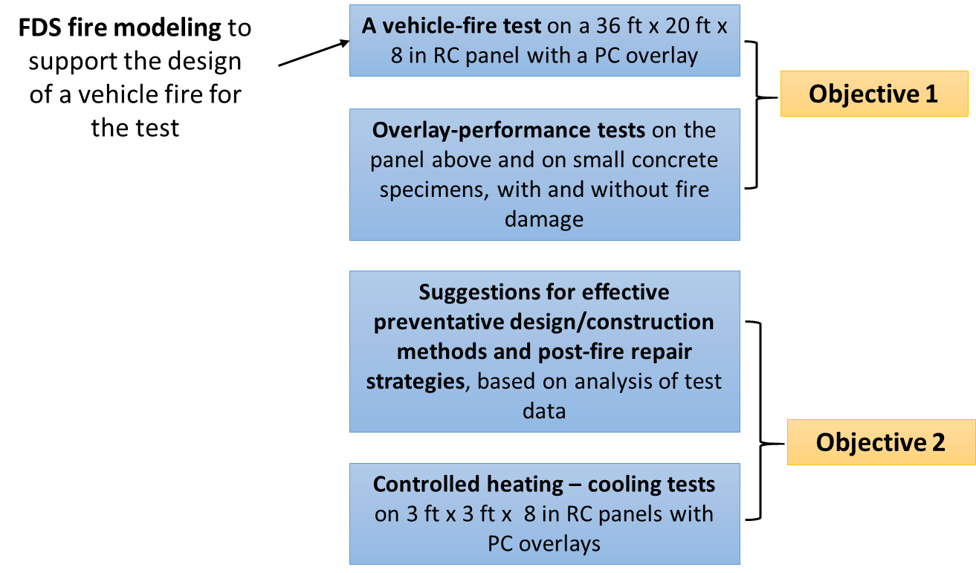
Figure 3 Overview of the research methods and their relationship to the objectives
The first step is to design and construct RC panels and concrete specimens with PC overlays according to the UDOT Structures Design & Detailing Manual [14]. These panels include 1) one 36 ft x 20 ft x 8 in RC panel (Figure 4; hereafter, “large RC panel”); 2) multiple 3 ft x 3 ft x 8 in RC panels (hereafter, “medium-sized RC panels”); and 3) multiple small concrete specimens. The large RC panel, representing a portion of a concrete bridge deck, will be subjected to a real vehicle fire. The medium-sized RC panels will be tested under controlled heating and cooling conditions, and the small concrete specimens will be used in overlay-performance tests. The binder for the large RC panel and small concrete specimens will be the one most commonly used in practice, as identified via literature review and expert interviews with engineers and transportation officials.
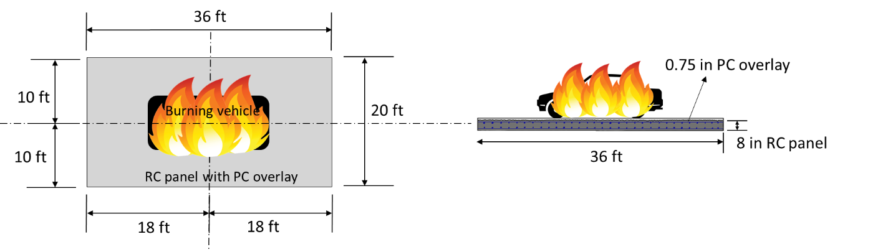
Figure 4 A vehicle fire test on a large RC panel overlaid by PC
The characteristics of vehicle fires that expose bridge decks to intense heat (e.g., fuel type, amount, location, and spread, ignition location, peak heat release rate (HRR), time to peak HRR, and burning duration) will be identified from the data in the Motor Vehicle Fire Research Institute (MVFRI) vehicle-burning dataset [15] and National Fire Data Center [16], [17], among other sources [18]–[21]. The vehicle fire in this study will be designed in accordance with those characteristics. FDS fire-modeling techniques will then be validated and used to simulate the designed vehicle fire, to ensure that its behavior is similar to that of severe vehicle fires in the real world [21-23], and thus that the damage to the PC overlay sustained during the vehicle-fire test is representative of that suffered by PC bridge deck overlays in actual fires of this type.
During the vehicle-fire test on the large RC panel, thermocouples, plate thermocouples and IR cameras will be used to record the following data: 1) flame temperature, 2) temperature distribution over the surface of the panel, 3) spatial distribution of heat flux to the surface of the panel, 4) gas temperature near the surface of the panel, and 5) temperatures at multiple depths within the panel, especially at the interface between the overlay and its concrete substrate. The entire fire test will also be recorded with a video camera. After the fire test, damage to the overlay and its concrete substrate (e.g., melting, delamination, cracks, and spalling) will be measured and recorded via visual inspection, ultrasonic pulse velocity tests, etc. The fire will be extinguished by firefighters after it burns for the designed duration. It is possible that firefighting techniques will inflict further damage on the PC overlay, which will be considered in the analysis of test data.
Post-fire, once the large RC panel has dried and cooled to ambient temperature, the residual performance of the fire-damaged overlay will be evaluated in terms of its residual: 1) skid resistance, via sand-patch tests [25], 2) bond strength between the overlay and the concrete substrate, via pull-off tests [26], 3) water-penetration resistance, via water-penetration tests [27], 4) chloride-permeability resistance, via rapid chloride permeability test [28], and 5) abrasion resistance, via abrasion tests [29]. These results will be compared against the performance of PC overlays without fire damage.
Based on the data from the vehicle-fire and overlay-performance tests, suggestions will be provided to enhance the vehicle-fire resistance of PC bridge deck overlays, in terms of material selection, construction practices, post-fire repair, etc. Those recommendations will be tested on medium-sized RC panels. Instead of real vehicle fires, those panels will be tested under controlled heating and cooling conditions, using electronic heating devices such as a Heat-Transfer Rate Inducing System (H-TRIS) [30].

Expected Outcomes
The expected outcomes of this project will: 1) inform engineers of the potential problems that intense heat from vehicle fires may cause to PC bridge deck overlays, 2) provide preventive design/construction suggestions for PC overlays, 3) provide fire-specific repair strategies for PC overlays, and 4) provide useful information for producing high-fire-resistance PC. Moreover, the recorded vehicle-fire test data and the developed vehicle-fire modeling techniques from this project can be used for any future research about the impacts of vehicle fires on highway infrastructure. Last but not least, the PI’s will collaborate with the local fire department in the vehicle fire test, which will provide them with training on vehicle firefighting.

Relevance to Strategic Goals
This project directly relates to the USDOT strategic goal of State of Good Repair that aims to ensure that the U.S. proactively maintains critical transportation infrastructure in a state of good repair. Knowledge from this project will guide the design, construction, and maintenance of PC bridge deck overlays to make them more resistant to vehicle fires, which is particularly important for those bridges whose damage due to vehicle fires will lead to severe transportation network interruption.

Educational Benefits
A Ph.D. level graduate student and an undergraduate student worker will be engaged in this project. Before the vehicle fire test, both students will be provided fire safety training. The Ph.D. student will take the lead on most tasks in this project, while the undergraduate student work will help the Ph.D. student with all the experimental tests. The Ph.D. student will gain general project management, communication, writing, and data management skills, as well as discipline-specific skills such as modeling fire in FDS, designing an instrumentation plan for a fire test, evaluating pavement’s performance, etc. The active involvement of the undergraduate student will not only equip the student with research and communication skills but also encourage her/him to pursue higher education. The PI also participates in the USU College of Engineering’s annual summer program for high school juniors, Engineering State. The PI is currently developing a bridge-fire-related module to be presented during this program.

Technology Transfer
The results of this research will be disseminated in the following ways: 1) research results will be presented at local, national and/or international conferences such as the annual UDOT Engineering Conference and the Annual Transportation Research Board Meeting; 2) the final report will be sent to staff colleagues at state and local transportation agencies; 3) two manuscripts will be prepared and submit them for publication in journals related to highway infrastructure and construction materials; 4) a webinar will be arranged through the Mountain Plains Consortium; and 5) all presentations, articles, and the final report will also be shared on the PI’s research website (https://sites.google.com/view/shunani/home). Since this project will involve a real vehicle fire test, the research results from this test could also be presented in fire-related conferences, such as the International Symposium on Fire Safety Science. A manuscript about this test and the FDS vehicle-fire modeling will be submitted to fire-related journals, such as Fire Safety Journal and Fire Technology.

Work Plan
The proposed project will be carried out over a 12-month period:
Task 1 (1 month): Literature review. The following information needs to be identified through literature review: 1) the type of PC most commonly used in practice for bridge deck and its recommended mix ratios; 2) the current design and construction practices for PC overlays; and 3) the characteristics of vehicle fires that expose bridge decks to intense heat.
Task 2 (1 month): Design and construct RC panels and concrete specimens with PC overlays. One large RC panel, multiple medium-sized RC panels, and multiple small concrete specimens will be designed and constructed. Additionally, the instrumentation plan will also be designed and implemented in the construction.
Task 3 (2 months): Design a vehicle fire for the fire test. The vehicle fire will be designed in accordance with those characteristics identified from the literature review. FDS fire-modeling techniques will then be validated and used to simulate the designed vehicle fire to ensure that its behavior is similar to that of severe vehicle fires in the real world.
Task 4 (2 months): Vehicle fire test on the large RC panel with a PC overlay. Temperature, heat flux, fire spread, and panel damage after the vehicle fire will be measured and recorded.
Task 5 (1 month): Performance tests on PC overlays with and without fire damage. The investigated overlay performance includes skid resistance, bond strength, water-penetration resistance, chloride-permeability resistance, and abrasion resistance. The skid resistance and the bond strength will be measured on the large RC panel directly before and after the vehicle fire, and the latter three will be measured on concrete cores drilled from the damaged large RC panel and intact small concrete specimens. The performance of fire-damaged PC overlays will be compared to that of intact overlays.
Task 6 (3 months): Propose and test preventive design recommendations and post-fire repair strategies. Based on the data from the vehicle-fire and overlay-performance tests, suggestions will be provided to enhance the vehicle-fire resistance of PC bridge deck overlays. Those recommendations will be tested on medium-sized RC panels under controlled heating and cooling conditions.
Task 7 (2 months): Final Report. A final report will document the results of Tasks 1 through 6 with an emphasis on reporting practical implications to transportation decision makers.

Project Cost
Total Project Costs: $ 160,000
MPC Funds Requested: $ 80,000
Matching Funds: $ 80,000
Source of Matching Funds: PI’s startup funding, non-resident tuition of the Ph.D. student, and faculty time & effort

References
[1] “U.S. Highway Vehicle Fires 1980-2019 | Statista,” Statista. https://www.statista.com/statistics/377006/nmber-of-us-highway-vehicle-fires/ (accessed Mar. 23, 2021).
[2] U.S. Fire Administration, “Vehicle Fires What You Need to Know.” Federal Emergency Management Agency, Aug. 2013, Accessed: Apr. 08, 2021. [Online]. Available: https://www.usfa.fema.gov/downloads/pdf/publications/fa-243.pdf.
[3] Kentucky Transportation Cabinet, “Brent Spence Bridge.” https://brentspencerepair.com/ (accessed Mar. 23, 2021).
[4] R. Allahverdizadeh, R. Rashetnia, A. Dousti, and M. Shekarchi, “Application of Polymer Concrete in Repair of Concrete Structures: A Literature Review,” presented at the 4th International Conference on Concrete Repair, Jan. 2011, doi: 10.13140/2.1.4893.7925.
[5] J. Dahlberg and B. Phares, “Polymer Concrete Overlay Evaluation,” Bridge Engineering Center, Iowa State University, InTrans Project 13-463, Jun. 2016.
[6] Wikipedia contributors, Polyethylene terephthalate — Wikipedia, The Free Encyclopedia. 2021.
[7] “Polyesters,” Polymer Properties Database, May 15, 2020. https://polymerdatabase.com/polymer%20classes/Polyester%20type.html (accessed Apr. 08, 2021).
[8] Wikipedia contributors, Poly(methyl methacrylate) — Wikipedia, The Free Encyclopedia. 2021.
[9] “Polymer Overlays for Bridge Decks - College of Engineering & Applied Science.” https://uwm.edu/engineering/polymer-overlays-for-bridge-decks-fall-academic-edition/ (accessed Apr. 09, 2021).
[10] A. Smith, “Overlaying Concrete Bridge Decks with Polymer Concrete,” Concrete Construction, Apr. 1991.
[11] K. S. Yeon, K. K. Kim, C. Y. Kim, and J. H. Yeon, “Coefficient of Thermal Expansion of Polymer Concrete with Different Polymeric Binders,” Adv. Mater. Res., vol. 1129, pp. 139–144, Nov. 2015, doi: 10.4028/www.scientific.net/AMR.1129.139.
[12] Nuno Gama, “Durability of Epoxy Polymer Concrete Overlays for Bridge Decks,” Department of Civil Engineering and Applied Mechanics, McGill University, Montreal, Canada, 1999.
[13] M. M. Sprinkel, “Thermal Compatibility of Thin Polymer-concrete Overlays,” Transp. Res. Board, no. 889, pp. 64–73, 1983.
[14] Utah Department of Transportation, Structures Design and Detailing Manual. Salt Lake City, Utah, 2017.
[15] M. L. Janssens and M. G. MacNaughton, “Development of a Database of Full-scale Calorimeter Tests of Motor Vehicle Burns,” Southwest Research Institute, Houston, Texas, SwRI Project No. 01.06939.01.003, Mar. 2008. [Online]. Available: http://www.mvfri.org/contracts/Final%20Reports/SWRI%20Vehicle%20Burns%20R06939-01-003.pdf.
[16] U.S. Fire Administration, “Highway Vehicle Fires (2014-2016),” Federal Emergency Management Agency, Emmitsburg, MD, Jul. 2018. [Online]. Available: https://www.usfa.fema.gov/downloads/pdf/statistics/v19i2.pdf.
[17] “Statistical Reports on the U.S. Fire Problem,” U.S. Fire Administration, Mar. 09, 2021. https://www.usfa.fema.gov/data/statistics/reports/ (accessed Apr. 06, 2021).
[18] A. Lecocq, M. Bertana, B. Truchot, and G. Marlair, “Comparison of the Fire Consequences of an Electric Vehicle and an Internal Combustion Engine Vehicle,” presented at the 2th International Conference on Fires in Vehicles - FIVE 2012, Chicago, United States, Sep. 2012.
[19] H. Masuda and W. Takahashi, “Experimental Investigation of Burning Behavior of Automobiles,” presented at the 6th Asia-Oceania Symposium on Fire Science and Technology, Daegu, Korea, Mar. 2004, [Online]. Available: https://www.iafss.org/publications/aofst/6/6b-5/view/aofst_6-6b-5.pdf.
[20] Technical Committee on Road Tunnel and Highway Fire Protection, “NFPA 502 Standards for Road Tunnels, Bridges and Other Limited Access Highways,” National Fire Protection Association, Quincy, Massachusetts, 2020.
[21] W. Wright, B. Lattimer, M. Woodworth, M. Nahid, and E. Sotelino, “Highway Bridge Fire Hazard Assessment Draft Final Report,” Virginia Polytechnic Institute and State University, Blacksburg, VA, Project No. 12-85, Sep. 2013. [Online]. Available: http://onlinepubs.trb.org/onlinepubs/nchrp/docs/NCHRP12-85_FR-Appendices.pdf.
[22] L. Halada, P. Weisenpacher, and J. Glas, “Computer Modelling of Automobile Fires,” in Advances in Modeling of Fluid Dynamics, C. Liu, Ed. InTech, 2012.
[23] D. Zigar, M. Blagojevic, and R. Radovanovic, “Simulation of Motor Vehicle Fires in Forensic Engineering,” Nauka Bezb. Polic., vol. 22, no. 3, pp. 107–121, 2017, doi: 10.5937/nabepo22-14330.
[24] K. B. McGrattan and G. P. Forney, “Fire Dynamics Simulator - User’s Manual,” National Institute of Standards and Technology, Gaithersburg, MD, NIST IR 6469, 2000. doi: 10.6028/NIST.IR.6469.
[25] W. P. Chamberlin and D. E. Amsler, “Measuring Surface Texture by the Sand-patch Method,” STP 763, HS-035 451, HS-035 452, 1982. [Online]. Available: https://trid.trb.org/view/201779.
[26] D01 Committee, “Test Method for Pull-Off Adhesion Strength of Coatings on Concrete Using Portable Pull-Off Adhesion Testers,” ASTM International. doi: 10.1520/D7234-19.
[27] B/517/1, BS EN 12390-8:2019 Testing Hardened Concrete Depth of Penetration of Water under Pressure. BSI, 2019.
[28] C09 Committee, “Test Method for Electrical Indication of Concretes Ability to Resist Chloride Ion Penetration,” ASTM International. doi: 10.1520/C1202-12.
[29] C09 Committee, “Test Method for Abrasion Resistance of Concrete or Mortar Surfaces by the Rotating-Cutter Method,” ASTM International. doi: 10.1520/C0944_C0944M-19.
[30] C. Maluk, L. Bisby, M. Krajcovic, and J. L. Torero, “A Heat-Transfer Rate Inducing System (H-TRIS) Test Method,” Fire Saf. J., vol. 105, pp. 307–319, Apr. 2019, doi: 10.1016/j.firesaf.2016.05.001.

